LOOVAY
The Formulator's Field Guide
A complete walkthrough of the Recipe Studio, the compliance engine, batch tracking, and every tool built to take a formula from idea to shelf.

Platform User Guide · www.loovay.app

Contents
Copyright & Distribution Notice 3
Welcome to Loovay 4
1. The Recipe Studio & Formulation Engine 5
2. The Math Under the Hood: Dual-Lye Stoichiometry 9
3. Fluid & Solvent Calculation Modes 11
4. The AI Alchemist & AURA Mentor 12
5. Compliance & Regulatory Guard 16
6. The Manufacturing Method Generator 21
7. The Master Ingredient Library 24
8. Financials & COGS Engine 26
9. Batch Log, Curing & Lot Traceability 29
10. The Adaptive Scale-Up Assistant 35
11. The Ad Copy Engine & Ad Library 37
12. Performance Analytics & Workspace Settings 39
13. Loovay Circle: Community & Peer Support 40
Quick Reference 44

Copyright & Distribution Notice
© 2026 Loovay. All rights reserved.
This guide, including its text, diagrams, screenshots, and layout, is the property of Loovay and is protected under applicable copyright law. No part of this document may be reproduced, copied, distributed, posted online, or transmitted in any form or by any means — electronic, mechanical, photocopying, recording, or otherwise — without the prior written permission of Loovay, except for brief excerpts used in reviews or internal training with attribution.
This document is provided for the use of Loovay account holders and authorized personnel only. It is not licensed for resale, redistribution, or publication, in whole or in part, on any external website, forum, marketplace, or competing product.
“Loovay” and its associated logos are trademarks of Loovay. All other product names, logos, and brands referenced are the property of their respective owners and are used for identification purposes only.
The formulation guidance, calculations, and regulatory information in this guide are provided for informational purposes only and do not constitute professional chemical, medical, or legal advice. See the disclaimers referenced throughout this guide for details.
Unauthorized distribution
If you received this guide outside an authorized Loovay account, please contact hello@loovay.app. Sharing your copy — internally or externally — outside the terms of your license agreement is a breach of that agreement and of applicable copyright law.

Document version 1.0 — issued September 2026. This notice applies to every page of this guide regardless of format (digital, printed, or converted).

Welcome to Loovay
Loovay is the workspace built for cosmetic formulators at any stage — the person mixing their first batch on a kitchen counter, the one turning a hobby into a small business, and the one running full production for an established brand. Whatever stage you're at, this is for anyone who mixes, weighs, and cures their own formulas, and who used to track it all across a notebook, a spreadsheet, three browser tabs, and a gut feeling.
This guide walks through every part of the platform in the order you'll actually touch it: building a recipe, checking the chemistry, generating compliant labels, tracking a batch through the cure rack, pricing it, marketing it, and talking to other formulators when something goes sideways on the bench.
Each chapter opens with the problem it solves, then walks through the screens step by step. Read it start to finish once, and keep it as a reference after that — you'll find yourself back in the compliance and financials chapters more than any other, whether you're formulating for the first time or the five-hundredth.

How the workspace is laid out
Everything lives behind one left-hand sidebar: Recipe Catalog, Add Recipe, Ingredient Library, Batch Log, Financials & COGS, Ad Copy Engine, Ad Library, Analytics, Settings, Billing & Plan, and Community Circle. Most of your time will be spent inside a single recipe — the Recipe Studio — where the formulation engine, compliance guard, AI mentor, method generator, and cost engine all sit on the same page, reacting to each other in real time.
Before you start
Every calculation in the studio is a theoretical estimate built from published SAP values and standard references. Bench testing, pH verification, and micro-testing before market are still on you — the engine gets you to a safe, well-reasoned starting point fast, not a shortcut around testing.

The Recipe Studio & Formulation Engine
“My studio notes are a chaotic mess scattered across phone apps, notebooks, and loose paper. When a batch turns out amazing, I can never remember the exact tweak that made it happen.”
What Loovay does about it
The Recipe Catalog and the Formulation Engine put every recipe, revision, and tweak in one place, and do the lye math for you as you build.

The Recipe Catalog
Open Recipe Catalog from the sidebar to see your whole formula library as cards — draft or production-ready, tagged by category and difficulty. Search by recipe name, ingredient, or tag; filter by category, skill level, or last-modified date; switch between grid and list view depending on whether you're browsing or hunting for one specific formula.
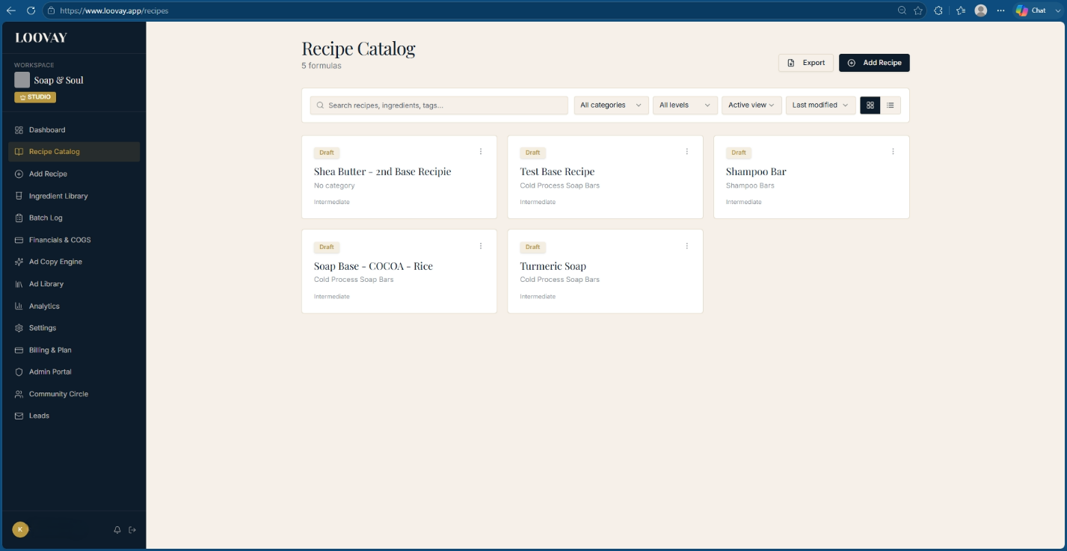
The Recipe Catalog: every formula as a card, filterable by category, level, and status.
Click + Add Recipe to open a blank formulation canvas. Give it a title, a product category, a target batch size, and a difficulty rating, then start logging ingredients and exact percentages. New formulas sit under a Draft badge until you're confident enough to mark them production-ready — so half-finished experiments never get mixed up with your real inventory recipes.
- Export your whole catalog for an offline backup or a print sheet for the studio table.
- Use the card's ⋮ menu to duplicate a recipe before testing a variation, instead of editing your working version.

Setting your batch size and oils
Inside a recipe, set Total Batch Oil Weight and pick your unit — grams, kilograms, ounces, or pounds. Add each oil, butter, or fat with its percentage of the total; the engine converts that instantly into a gram weight and keeps every downstream number (lye, water, yield) tied to it. Change the total batch weight later — scaling from a 300 g bench sample up to a 5 kg production run — and every ingredient mass updates automatically while the percentages stay exactly the same.
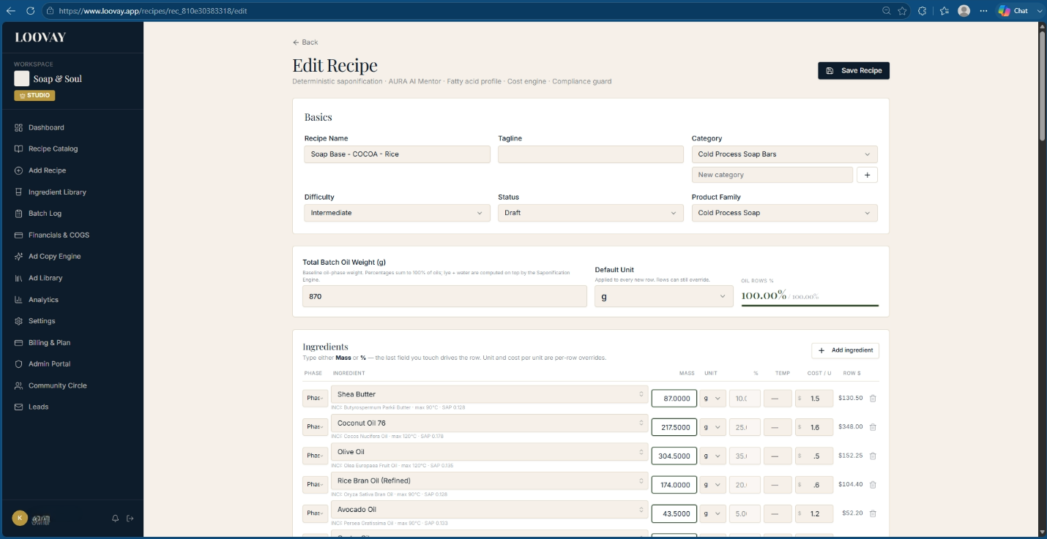
The Edit Recipe screen: basics, total batch weight, and the ingredient table with mass, %, and cost per unit.

The Saponification Engine
This is the mathematical core of the studio. It takes your lipid masses and works out exactly how much alkali is needed to turn them into soap, for cold process, hot process, liquid, or dual-lye formulas — while a live product mockup and a full fatty-acid readout update alongside it.
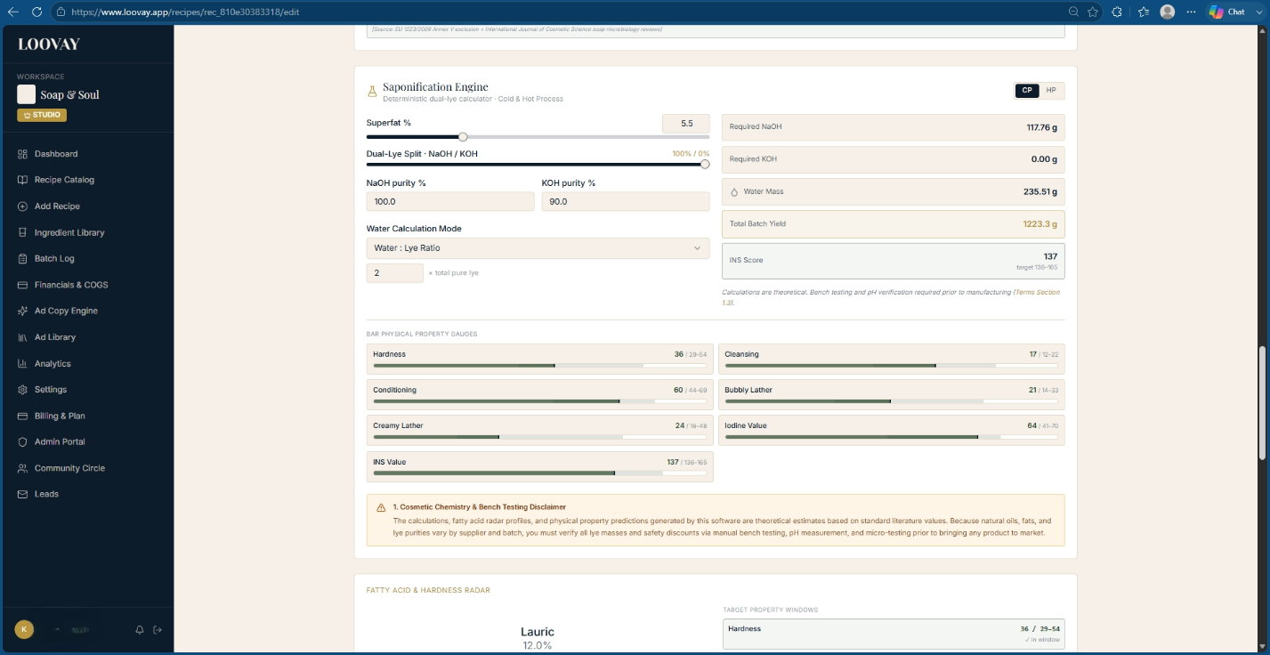
The Saponification Engine panel: superfat, dual-lye split, purity, and water mode, with results on the right.

Choosing your alkali
- Pure NaOH (sodium hydroxide) — the standard choice for solid bar soap.
- Pure KOH (potassium hydroxide) — used for liquid soap, with a purity slider (typically 85–95%) so the math matches your actual raw material, not an assumed 100%.
- Dual-lye blends — a custom NaOH/KOH split (say, 90/10) for cream soaps or bars with extra lather acceleration.
Formulator tip
When you're formulating liquid soap with KOH, set the purity slider to match your supplier's Certificate of Analysis exactly — 88.5%, not a rounded 90%. Calculate at full purity and your finished liquid soap will cloud with un-saponified oil and start separating.

Superfat and lye discount
Superfat is the percentage of oil left deliberately unreacted, and it swings from −10% to +30%:
- −10% to −1% (lye-heavy): high cleansing, built for laundry bars and heavy degreasers.
- 0% to +5% (standard): a balanced, stable bar with full lipid conversion.
- +6% to +30% (high-conditioning): unreacted oil left in the bar for a noticeably richer, more moisturizing finish — facial bars, body balms.

Water and liquid replacements
Set hydration either as a Water:Lye ratio (roughly 1.5:1 to 3:1) or as a percentage of oil weight (33–38% is typical). The engine auto-calculates a sodium phytate chelator dose (0.05–0.2%) for hard-water areas, which keeps orange spots and rancidity off your cured bars. You can also split the liquid phase across non-water bases — goat milk, coconut milk, aloe vera, floral hydrosols — and the engine accounts for the natural sugars in those, which heat batches faster and change your working time at trace.

Fatty acid profiling and the physical property scorecard
As you build, the engine tracks eight fatty acids across your oil blend — lauric, myristic, palmitic, stearic, ricinoleic, oleic, linoleic, and linolenic — and translates that into seven physical-property scores, each checked against an established target range.
Property | What it's built from | Target range | What high values mean
Hardness | Lauric + Myristic + Palmitic + Stearic | 29 – 54 | Long-lasting, firm bar; won't slough
Cleansing | Lauric + Myristic | 12 – 22 | Deep stripping power; drying above 22
Conditioning | Oleic + Linoleic + Linolenic + Ricinoleic | 44 – 69 | Soothing, moisturizing, softer bar
Bubbly lather | Lauric + Myristic + Ricinoleic | 14 – 46 | Fast, big flash foam
Creamy lather | Palmitic + Stearic + Ricinoleic | 16 – 48 | Dense, stable, lotion-like foam
Iodine value | Unsaturation index (g I₂/100g) | 41 – 70 | Above 70 risks a soft bar and rancidity
INS score | SAP value − Iodine value | 136 – 165 | Overall bar-balance benchmark

The product mockup
As you adjust oils, botanicals, colorants, and packaging format, the engine renders a live, photorealistic mockup of the finished product — color and opacity derived from oil hue and any clay or mica added, texture and sheen predicted from wax content and fatty acid hardness, and the container automatically matched to product type: a molded bar, an amber bottle, or a cream jar.
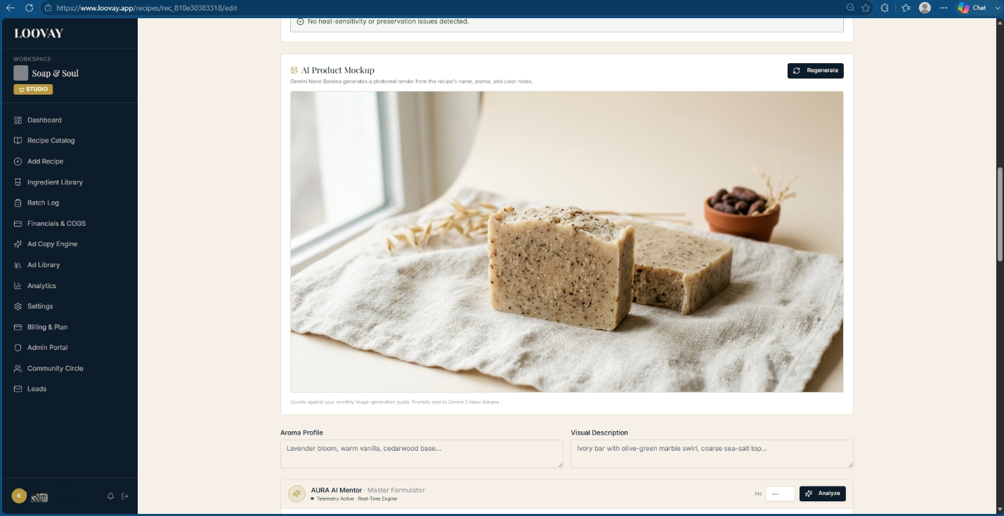
The Product Mockup Engine rendering color, texture, and packaging in real time as the formula changes.

Building a balanced recipe, step by step
- Open the Formulation Engine workspace and add your base oils with target percentages (e.g. 40% olive, 30% coconut, 20% palm, 10% castor).
- Enter your total target oil weight.
- Choose your alkali type (NaOH, KOH, or a dual-lye split) and set purity to match your supplier's COA.
- Set your target superfat.
- Pick a water:lye ratio and, if you're using milk or juice, split the liquid phase accordingly.
- Check the fatty acid scorecard — if cleansing reads above 22, pull back coconut oil and add more olive.
- Confirm iodine stays under 70 for shelf stability, then preview the mockup before you stage the batch.

The Math Under the Hood: Dual-Lye Stoichiometry
“Calculating lye ratios and water discounts across changing batch sizes gives me constant anxiety. One wrong decimal point and a whole batch goes into the trash — or worse, burns someone's skin.”
What Loovay does about it
The stoichiometry engine runs the exact molecular math behind every lye calculation, so a typo in a spreadsheet cell can't turn into a caustic batch.

Sodium hydroxide (NaOH, molar mass ≈ 39.997 g/mol) and potassium hydroxide (KOH, molar mass ≈ 56.105 g/mol) don't saponify oil in the same proportions, because they don't weigh the same per mole. Any dual-lye recipe has to correct for that difference, and the engine does it in four steps.

Step 1 — Baseline pure NaOH requirement
For every lipid in the recipe, multiply its mass by its NaOH SAP value, then add them all together. That total is the 100%-pure NaOH the recipe would need at zero superfat.

Step 2 — Apply the superfat discount
Multiply that baseline by (1 − superfat), where superfat is written as a decimal. A 5% superfat becomes 0.05.

Step 3 — Split across NaOH and KOH
Multiply the discounted total by your NaOH ratio to get the pure NaOH portion. For the KOH portion, multiply by the KOH ratio, then by the molar-mass conversion constant — 56.105 ÷ 39.997, which comes out to roughly 1.40275 — because it takes more KOH by weight to do the same job.

Step 4 — Correct for raw material purity
Industrial NaOH commonly tests at 98% purity; technical-grade KOH pellets typically run 85–90%, carrying trace moisture and carbonates. Divide each pure-alkali target by its actual purity (as a decimal) to get the real number to put on the scale.
Formulator tip
Always enter your exact KOH purity from the supplier's COA — 88.5%, not a rounded 90% or an assumed 100%. Get this wrong and the finished batch comes out under-saponified: soft, greasy, or separated.

Worked example: a dual-lye shaving soap
Batch: 600 g stearic acid, 300 g coconut oil, 100 g castor oil (1000 g total). Target superfat 5%. Split: 60% KOH / 40% NaOH. Purities: NaOH 98%, KOH 90%.
Lipid | Mass | SAP (NaOH) | Baseline pure NaOH
Stearic acid | 600 g | 0.141 | 84.60 g
Coconut oil | 300 g | 0.183 | 54.90 g
Castor oil | 100 g | 0.129 | 12.90 g
Total | 1000 g | — | 152.40 g

- After the 5% superfat discount: 152.40 g × 0.95 = 144.78 g pure NaOH-equivalent.
- NaOH share (40%): 144.78 × 0.40 = 57.912 g pure NaOH.
- KOH share (60%): (144.78 × 0.60) × 1.40275 = 121.854 g pure KOH.
- Raw NaOH to weigh out: 57.912 ÷ 0.98 = 59.09 g.
- Raw KOH to weigh out: 121.854 ÷ 0.90 = 135.39 g.
That's the entire calculation the engine runs the instant you touch the superfat slider or the purity field — recalculated live, every time.

Fluid & Solvent Calculation Modes
Changing your superfat, lye purity, or dual-lye split all shift how much active alkali is in the recipe — and that changes how much water or liquid you need to dissolve it cleanly. Rather than force one convention, the engine gives you three interchangeable ways to set fluid mass, and recalculates all three live whenever an upstream number changes.

Mode 1 — Percent of total oil weight
Fluid mass = total lipid mass × your target percentage. This is the traditional artisan cold-process metric, independent of how much lye is in the recipe. Typical range: 30–38% of oil weight. Best for standard, balanced cold-process recipes.

Mode 2 — Lye concentration percentage
Fluid mass = (total raw lye mass ÷ concentration) − total raw lye mass. This is the industrial-chemistry standard, because reaction speed and heat output depend directly on how concentrated the lye solution actually is. Typical range: 25–50%. Best for advanced swirl work (28–30%), fast mold-release or discounted-water batches (33–38%), and hot process (25–28%).

Mode 3 — Fluid-to-lye ratio
Fluid mass = total raw lye mass × a ratio multiplier. The most intuitive way to stay above the solubility floor — pure NaOH needs at least a 0.9:1 water-to-lye ratio to fully dissolve at room temperature, and the engine flags anything under 1.1:1 as a solubility risk. Typical range: 1.5:1 to 3:1.
Mode | Best for | Main risk
% of oil weight | Simple cold-process soaps at standard superfat | Can run too wet with low-SAP oil blends
Lye concentration % | Multi-color swirls, liquid soap, castile | Concentrations above 40% accelerate trace fast
Fluid-to-lye ratio | Shaving soaps, cream soaps, dual-lye hybrids | Needs re-tuning when switching single/dual-lye

Formulator tip
Working with milk or sugar-heavy liquids — goat milk, aloe vera, beer? Switch to Mode 2 and target 30–33% concentration. That keeps fluid volume low enough to avoid scorching sugars, while still giving the lye enough solvent to fully dissolve.

The AI Alchemist & AURA Mentor
“I pour money down the drain every week testing new formulas. Waiting weeks for a batch to cure just to discover it strips the skin or loses its lather is soul-crushing.”
What Loovay does about it
Click Analyze Formula and the AI Alchemist runs a full pre-execution simulation — chemistry, sensory feel, and safety — before you weigh out a single oil.

The Alchemist behaves like an on-call cosmetic chemist and a supportive peer formulator in one panel. Instead of a dry error log, clicking Analyze Formula produces a two-part narrative: a technical simulation, then a prediction of exactly what the finished product will feel like in a customer's hands.
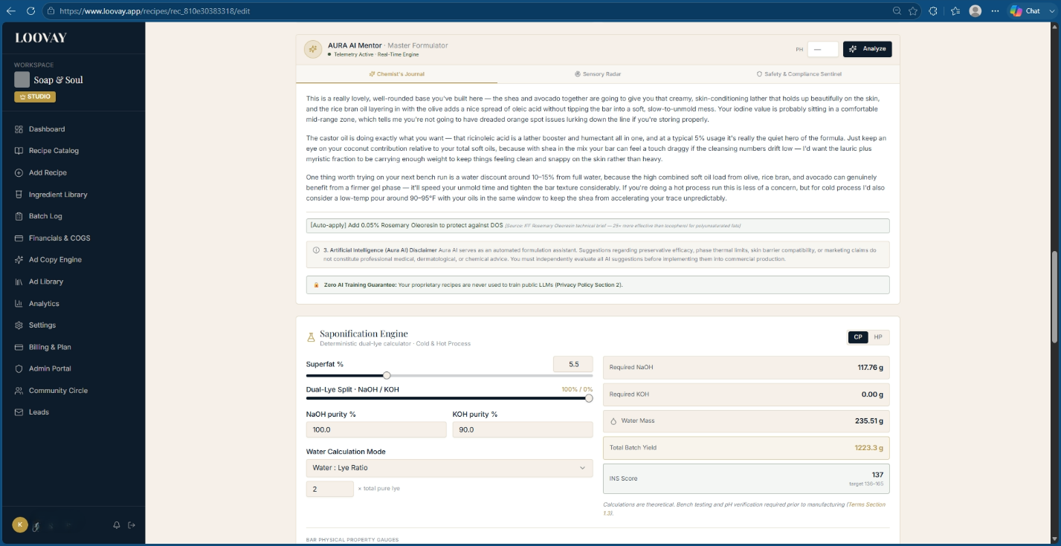
The AI Alchemist Virtual Mentor Engine — chemistry review paired with a customer sensory forecast.

What it checks automatically
- Thermal sensitivity — flags heat-vulnerable actives (retinol, niacinamide, delicate essential oils) sitting in a phase heated above 40°C, and suggests moving them to a cool-down phase.
- Preservation — triggers an immediate warning if any water-containing phase has no broad-spectrum preservative attached, since an unpreserved aqueous formula grows microbes within days.
- Sensory and tactile forecast — reads the ratio of light-to-heavy esters, waxes, and humectants to predict the finished skin feel (for example: 'a rich, slow-absorbing velvet finish, ideal for a night cream').

Phase A: the pre-execution simulation
This section calls out what's working — synergistic pairings like vitamin E with rosemary oleoresin, or niacinamide with hyaluronic acid — and flags latent risks in plain language: potential emulsion shearing, pH drift, oxidation, or soaping. Every flag comes with a specific, percentage-level fix you can apply with one click.
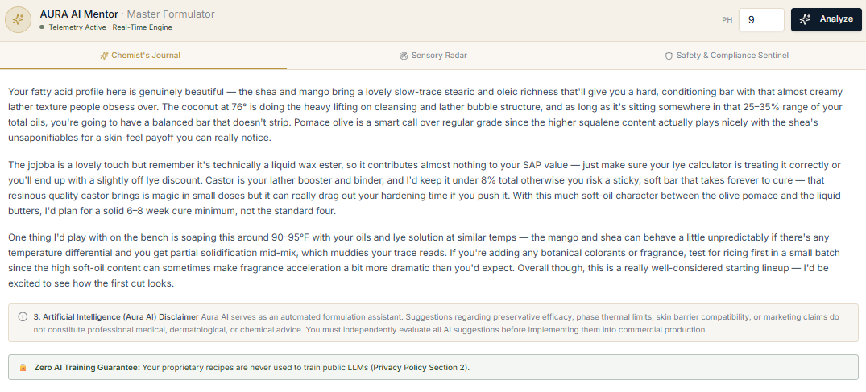
The Chemist's Journal tab — a plain-language read on the formula's fatty acid balance, cure timing, and bench risks.

Phase B: the customer sensory prediction
The Alchemist walks the full physical journey of the product, in five stages:
- Visual & packaging — color, sheen, opacity, how it sits in the jar or bottle.
- First touch — pickup viscosity, cushion, bounce.
- Application — glide, spreadability, whether the emulsion transiently whitens or soaps during rub-in.
- Dry-down — the 5-minute finish versus the 8-hour barrier feel.
- Aroma evolution — top notes on application through to base notes hours later.
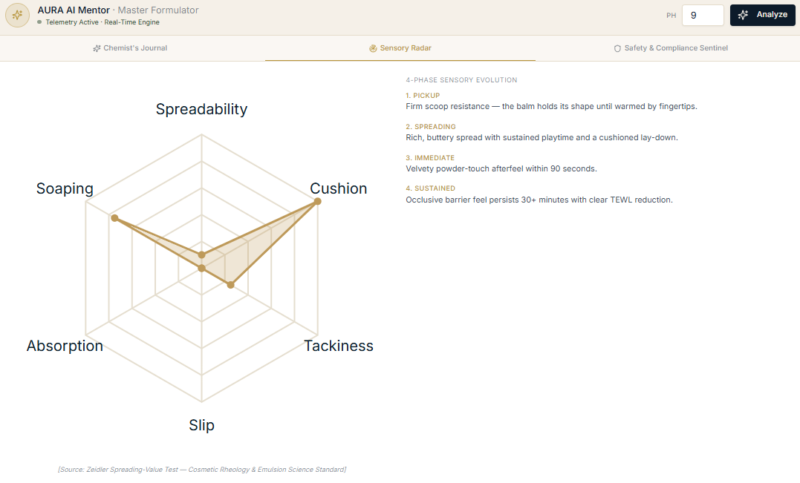
The Sensory Radar tab: spreadability, cushion, tackiness, slip, absorption, and soaping, plotted against a 4-phase sensory forecast.
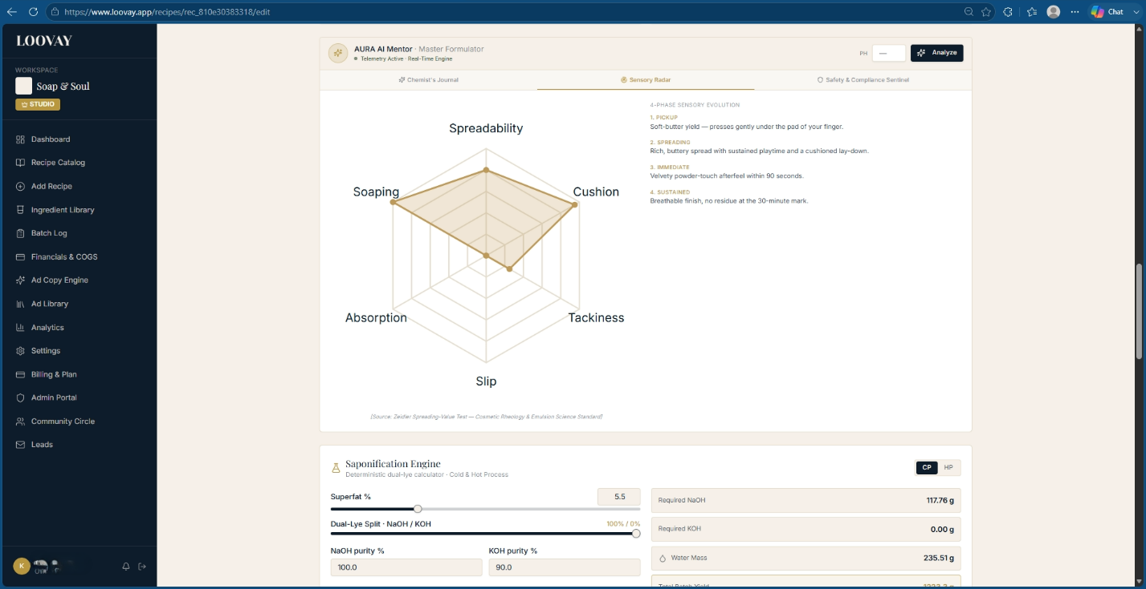
The Sensory Radar sits directly above the Saponification Engine on the same recipe page — chemistry and customer feel, side by side.
Formulator tip
If the Alchemist predicts your cream will 'whiten or soap during rub-in,' open its recommendation tab and add 1–2% dimethicone or isoamyl laurate — it breaks the surface tension causing the effect.

Reading the yield and property outputs
The same panel that runs the Alchemist's analysis also surfaces the underlying saponification numbers and physical-property gauges it's reasoning from — so you can see exactly why it flagged what it flagged.
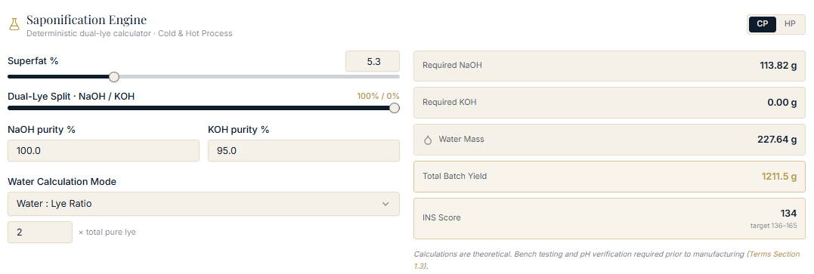
Saponification output feeding the mentor: required NaOH/KOH, water mass, total yield, and INS score.
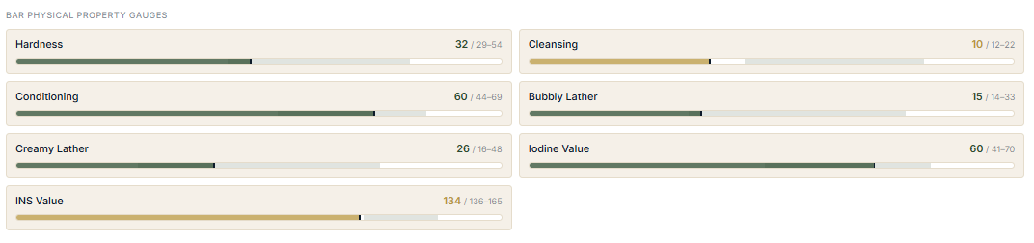
Bar Physical Property Gauges — each metric plotted against its target window, with the current value called out.
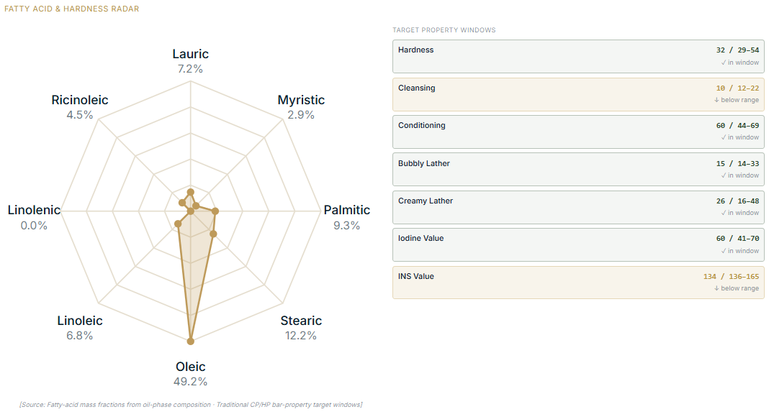
The Fatty Acid & Hardness Radar, with each property checked against its target range on the right.

The Safety & Compliance Sentinel
A third tab on the same panel checks the formula against four regulatory frameworks at once and surfaces any thermal or preservation risk in plain language underneath.
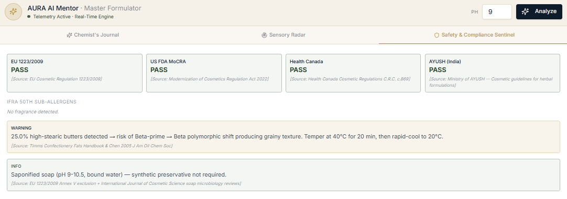
Safety & Compliance Sentinel: EU 1223/2009, US FDA MoCRA, Health Canada, and AYUSH (India) status, plus a bench-chemistry warning.

Running an analysis
- Stage your recipe, assigning every ingredient to Phase A (water), B (oil), or C (cool-down).
- Confirm usage rates and target application type are set.
- Click Analyze Formula in the top-right of the recipe toolbar.
- Review the pre-execution warnings, then click Apply Recommended Tweaks to accept a fix automatically.
- Read the sensory prediction to check it matches what you're marketing the product as.

Compliance & Regulatory Guard
“Formatting INCI lists, tracking down EU fragrance allergens, and building safety logs takes me days. I feel like a full-time compliance officer instead of a formulator.”
What Loovay does about it
One panel generates your legal INCI declaration, checks every fragrance allergen against IFRA limits, and screens your formula against major retailer blacklists — all from the same ingredient data you already entered.

The Regulatory, INCI & Compliance Guard reads your master formula and continuously checks it against four things at once: descending-weight INCI formatting, IFRA 50th Amendment allergen limits, retailer clean-beauty blacklists, and jurisdictional restricted-substance rules (US FDA, Health Canada, EU 1223/2009).

Automated INCI sorting rules
- Above 1% by weight: ingredients are locked into strict descending order, highest concentration first.
- At or below 1%: grouped after the >1% block, but freely reorderable — drag botanicals or actives forward for label storytelling without breaking compliance.
- Fragrance blends: consolidated under "Parfum" (EU/Canada) or "Fragrance" (US), with individually regulated allergens (limonene, linalool, citral, geraniol) auto-appended when they cross a disclosure threshold.
- Colorants: every color additive is placed at the very end of the deck and mapped to its official Color Index number — titanium dioxide becomes "CI 77891," red iron oxide becomes "CI 77491."

IFRA allergen aggregation
The engine sums each allergen's concentration across every essential oil and fragrance blend in the formula, then checks it against the disclosure threshold for how the product is used:
Product type | Disclosure trigger
Rinse-off (soap, shampoo, wash) | Above 0.01% (100 ppm)
Leave-on (lotion, cream, serum) | Above 0.001% (10 ppm)

It also checks the total fragrance load against the specific IFRA application category you select — Category 9 for rinse-off soap, Category 5A for leave-on body lotion — and throws a real-time breach alert if a blend exceeds the ceiling for that category, naming the exact constituent and the percentage to cut back to.
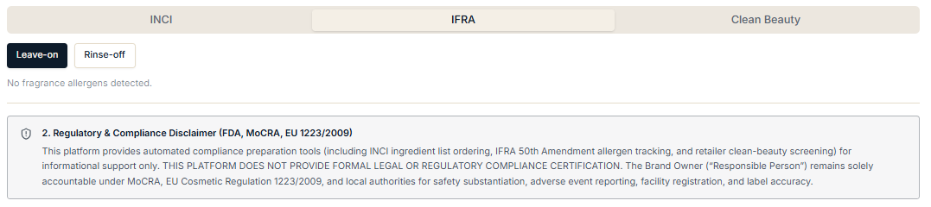
The IFRA tab — toggle Leave-on or Rinse-off to switch the allergen disclosure threshold applied below.
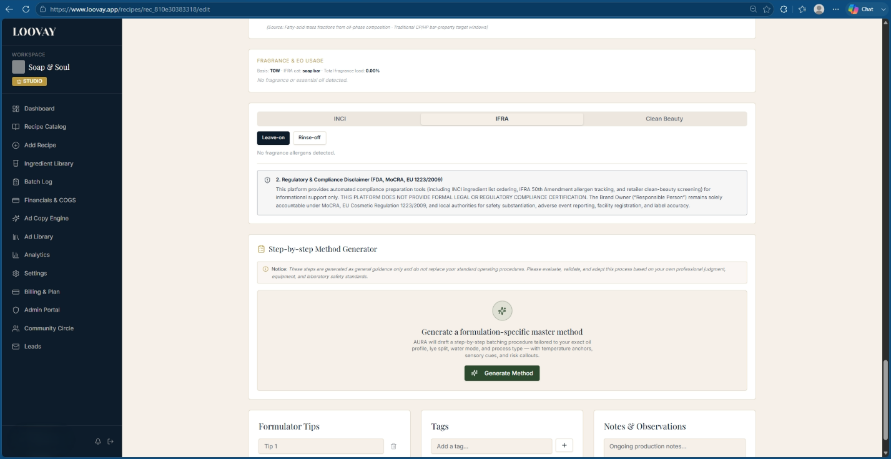
The IFRA tab in context: it lives directly above the Manufacturing Method Generator on the same recipe page.

Clean beauty & blacklist screening
Standard | What it screens for
Sephora Clean | Parabens, sulfates (SLS/SLES), phthalates, mineral oils, formaldehyde, cyclic silicones (D4/D5)
Credo Clean | The 2,000+ item Credo Dirty List, natural-origin claims, ethoxylated compound limits
EU 1223/2009 | Annex II (prohibited) and Annex III (restricted) substances

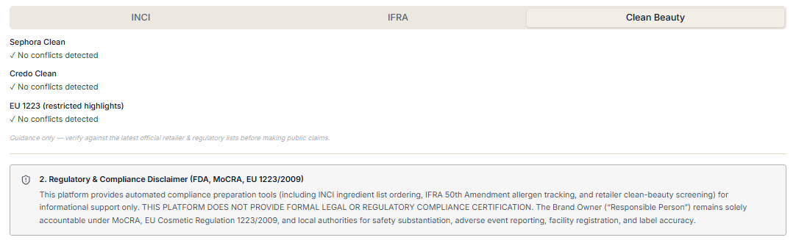
The Clean Beauty tab — a pass/fail read against each retailer or regulatory list, with a guidance note underneath.
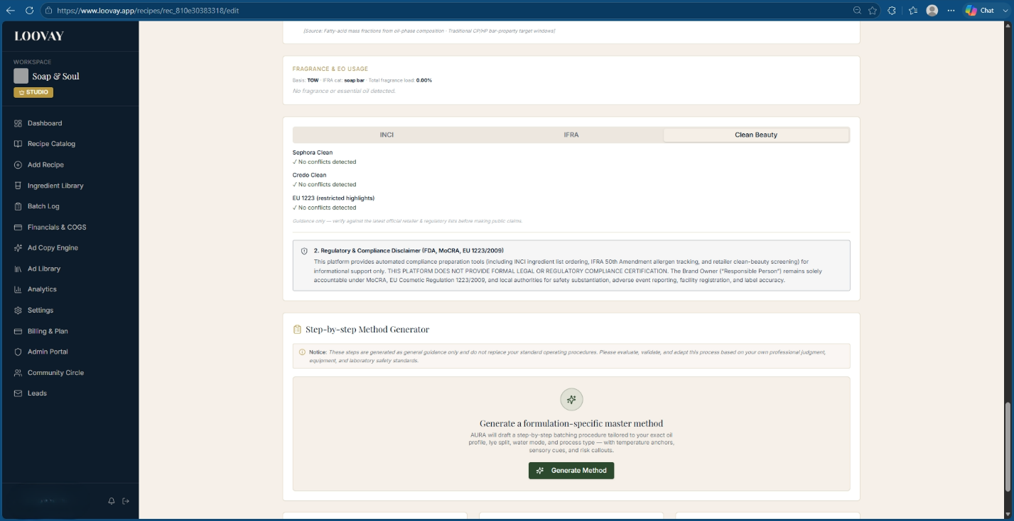
The Clean Beauty tab in full context, sitting above the Manufacturing Method Generator.

Running a compliance audit
- Open the Compliance Guard tab and set your product's application category — Category 9 (wash-off), 5A (leave-on lotion), or 5B (leave-on facial moisturizer).
- Check the retailer standards you want to screen against — Sephora Clean, Credo Clean, EU 1223/2009.
- Review status badges: green PASSED, or a red/yellow WARNING naming the specific non-compliant ingredient.
- Open the IFRA Allergen Summary Drawer to confirm every fragrance component sits under its disclosure limit.
- Click Generate Regulatory Compliance Certificate to export a dated PDF dossier — INCI statement, IFRA pass report, allergen summary, and blacklist audit — for your records.
Formulator tip
Formulating a leave-on product? Check essential-oil usage rates before you finalize batch size. Oils high in citral, or bergapten-containing citrus oils, often carry safe-use ceilings below 1.0% — easy to miss if you're used to soap-only percentages.

Multi-region status, at a glance
The same Safety & Compliance Sentinel that backs the AI Alchemist also sits inside the compliance workflow, giving a single pass/fail read across every jurisdiction you sell into before you touch the INCI generator.
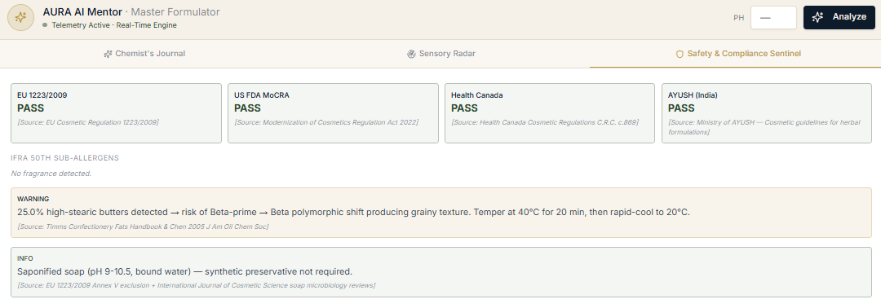
Safety & Compliance Sentinel — EU, US, Canada, and India status in one row, with any bench-chemistry warning below it.
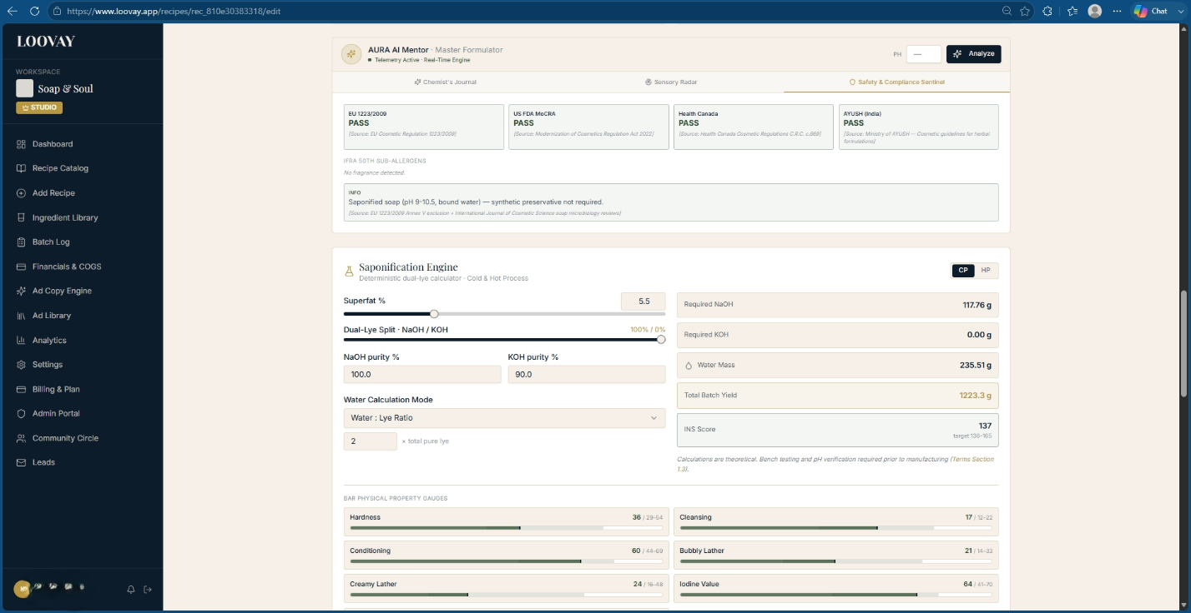
The Sentinel sits directly above the Saponification Engine — regulatory status and lye math on the same screen.

The Legal INCI Label Generator
This is the export layer that turns compliant formula data into a print-ready ingredient declaration for the US, Canada, or the EU — with one important choice specific to soap: pre-saponified or post-saponified format.

Pre-saponified (US FDA default)
Lists the raw starting materials as they went into the pot, lye included, with Latin botanical names alongside their common English translation:
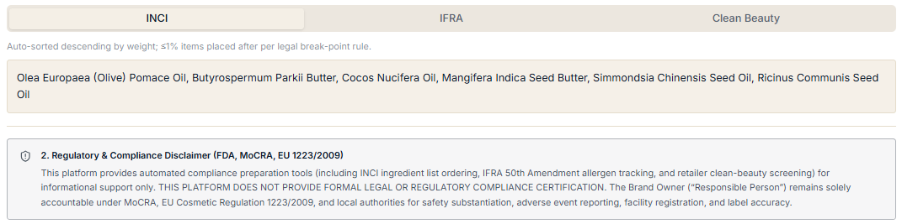
Example pre-saponified INCI output: raw oils and lye listed as added, before the reaction.

Post-saponified (EU / Health Canada)
Calculates the sodium or potassium carboxylate salts actually formed by the reaction — olive oil plus NaOH becomes "Sodium Olivate" — and auto-calculates the exact mass of glycerin produced as a reaction byproduct. Any intentional superfat oil left unreacted is listed separately under its raw INCI name.
Formulator tip
Selling in the US and want to claim "Contains Real Glycerin" on the label? You have to use the post-saponified format — glycerin only legally appears in the ingredient deck that way.

Generating a label
- Open your finished recipe and go to the Regulatory & Labeling tab.
- Choose your jurisdiction — US, Canada, or EU/UK — and toggle pre- or post-saponified format.
- Review the auto-sorted preview; ingredients above 1% show a locked descending-order badge.
- Drag sub-1% botanicals or colorants in the flexible block into your preferred label sequence.
- Click Copy INCI Text to paste directly into your labeling software, or Download Regulatory Dossier for a timestamped compliance record.

The Manufacturing Method Generator
Generic boilerplate instructions don't account for what's actually in your recipe. The method generator, found in the Manufacturing Method section of Add Recipe, compiles your entire active formula — fatty acid speed, water concentration, lye purity — and builds a temperature-anchored procedure specific to that batch.
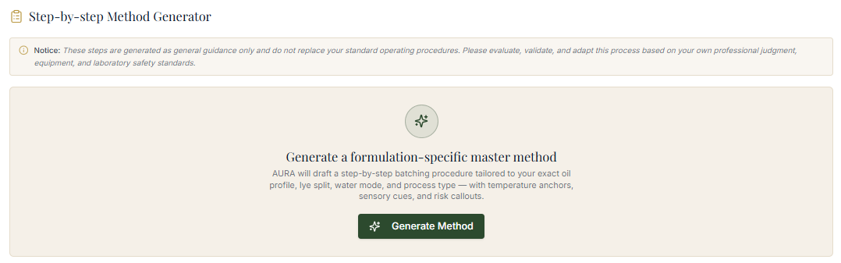
The Manufacturing Method Generator's starting card — one click drafts a procedure from your exact oil profile and lye split.

What gets generated

1. Before you begin
A pre-flight safety checklist: PPE suited to your actual chemicals (face shield and double-gloving for dual-lye or low-water batches), a vessel and equipment recommendation matched to batch mass and expected heat, and a pre-calculated staging list of every scale weight in addition order.

2. Phase-aware, temperature-anchored steps
- Lye solution prep — target water temperature, dissolution sequence for dual-lye (NaOH before KOH, to avoid a heat-driven boil-over), fume mitigation, cooling time.
- Oil phase prep — melting profile matched to your hardest fat, target oil temperature to avoid false trace or thermal shock.
- Emulsification & tracing — target temperature gap between lye and oil (generally within 5–10°F), blending cadence matched to how fast your fatty acid profile will trace.
- Molding or cooking — CP-specific pour and insulation guidance, or HP-specific cook-stage monitoring through the vaseline and translucent-gel phases.

3. Mentor observations
Formula-specific callouts flag exactly what to watch for — for example, a high-lauric, high-concentration recipe gets a direct warning to keep stick-blending under 15 seconds and have colorants and molds ready before combining phases, because trace will move fast.

4. Post-batching & curing
An unmolding window calculated from your recipe's hardness score, a cutting-timeline recommendation to avoid crumbling edges, and a cure duration (typically 4–6 weeks for CP water evaporation, or a pH-verification step for HP).

What the output actually looks like
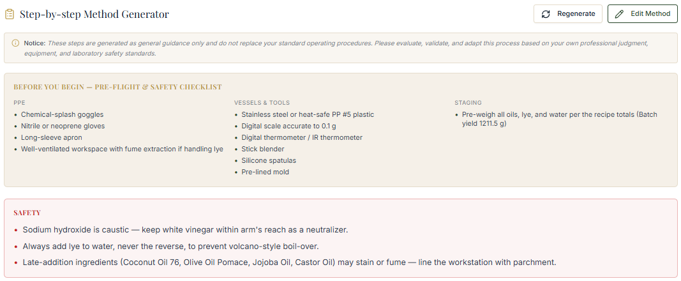
Before You Begin: PPE, vessels and tools, and a pre-weighed staging list — plus safety notes specific to the alkali in this recipe.
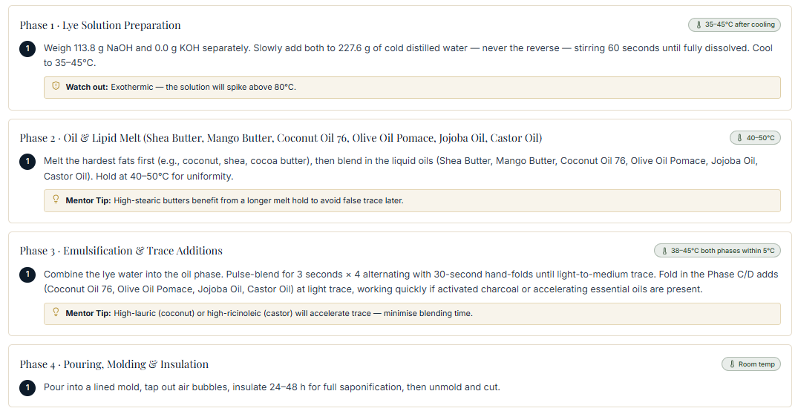
The phase-by-phase procedure — lye prep, oil melt, emulsification, and molding — each with its own target temperature and a mentor tip.
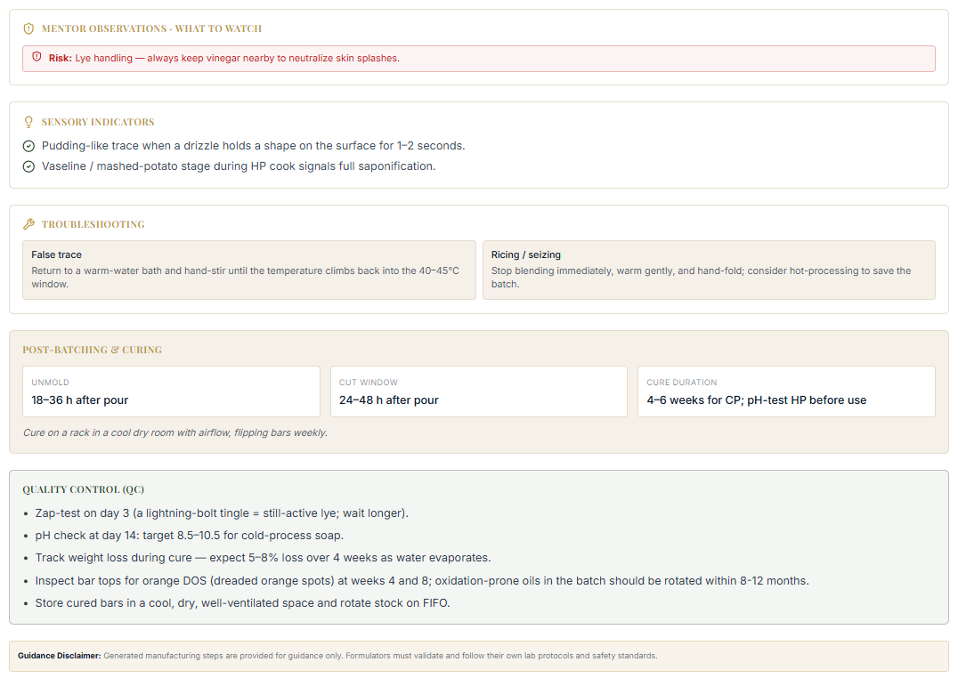
Mentor observations, sensory indicators, troubleshooting, and the post-batching QC checklist that closes out the generated method.

Generating a method
- Finish your recipe — target weights, process (CP or HP), superfat, and water ratio all confirmed in the summary panel.
- Scroll to Manufacturing Method and click Generate Method.
- Review the output for temperature targets and equipment setup, and add manual notes directly in the editor.
- Click Save Recipe to link the procedure to your batch logs and production runs.
Formulator tip
Added a fast-accelerating essential oil or changed your water discount after generating a method? Click Generate Method again — it updates the safety callouts and blending cadence to match your new formula.

The Master Ingredient Library
“Every time I want to try a new butter or clay, I end up down a rabbit hole of old textbooks and vendor sheets. I just want its SAP value, usage rate, and skin benefits in five seconds.”
What Loovay does about it
A single, verified database of 300+ raw materials — SAP constants, thermal limits, safety data, and sensory scores — searchable in one box.

The library ships pre-loaded across 14 functional categories: hard oils and butters, soft oils, waxes, emollients, water and humectants, thickeners and rheology modifiers, emulsifiers, surfactants, active extracts, powders, essential oils, additives and fragrance, and preservatives.
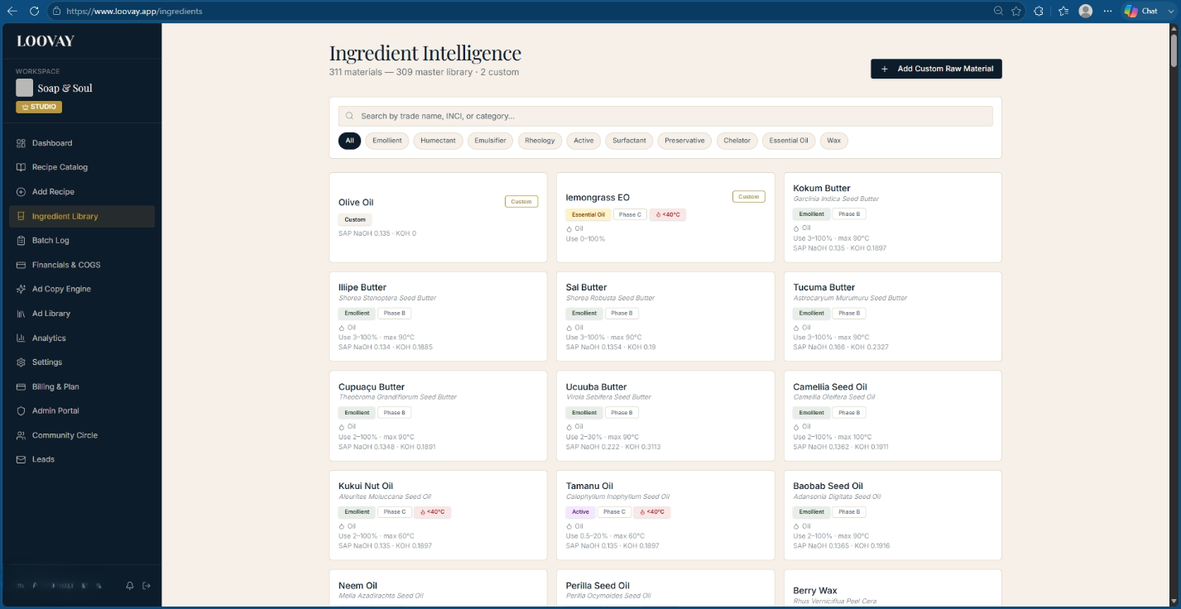
The Ingredient Library, filterable by category pill — Emollient, Humectant, Emulsifier, Active, and more.

What's in every ingredient record
- Formulation phase default — Phase A (aqueous), B (oil), C (cool-down/heat-sensitive), or D (pH adjusters/trace additives).
- Solubility and thermal limits, including an explicit heat-sensitivity flag for anything that degrades above 40°C.
- Regulatory badges — COSMOS, ECOCERT, USDA Organic, ISO 16128 natural-origin index, and any IFRA restriction.
- Dual SAP values (NaOH and KOH) for anything saponifiable.
- Tactile scores on a 1–5 scale for spreadability, cushion, tackiness, and slip.
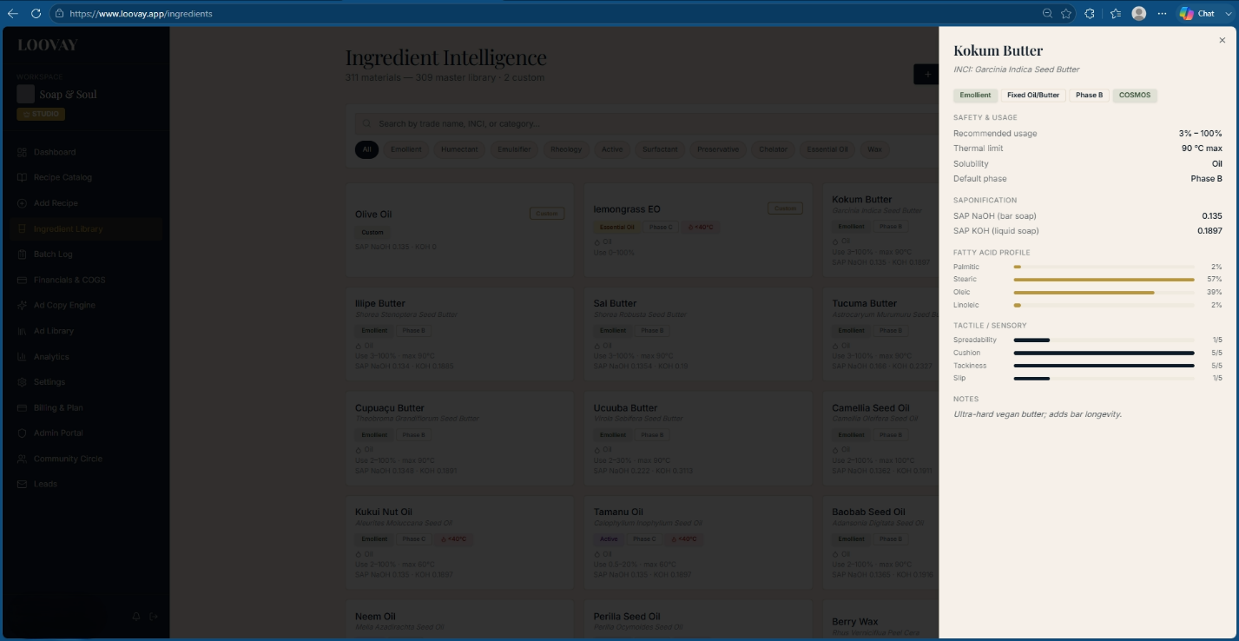
A full ingredient record — safety data, SAP constants, fatty acid breakdown, and tactile sensory profile.

Adding a custom raw material
Click + New Ingredient, enter the trade name and legal INCI name, and assign a functional category and default phase. For saponifiable lipids, enter both SAP values and the fatty acid breakdown; for functional actives, open the Biomarker Tracker to log the standardized active percentage — for instance, a green tea extract's EGCG concentration — so the engine can calculate the true active dose delivered in the finished formula, not just the raw material's inclusion rate.
Formulator tip
Flag any cold-pressed botanical extract containing active polyphenols or carotenoids as heat-sensitive below 40°C. That forces the formulation engine to assign it to Phase C automatically, protecting it from degrading during manufacture.

Financials & COGS Engine
“Raw material prices keep rising, but updating my cost spreadsheets is a nightmare. I know my revenue, but not my true cost per unit once packaging and scrap are factored in.”
What Loovay does about it
Raw material cost, packaging, and labor feed one live engine that gives you a true unit cost down to fractions of a cent, and a retail price locked to your target margin.

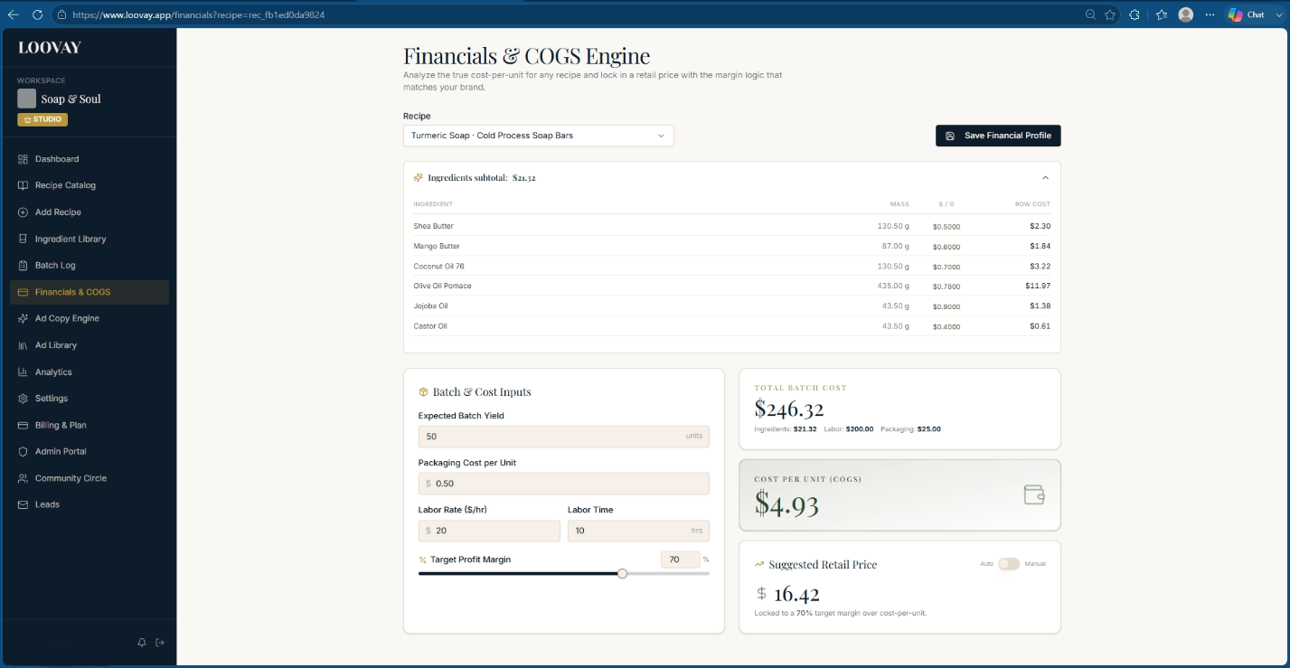
The Financials & COGS panel — total batch cost, unit COGS, and suggested retail price, updating live.
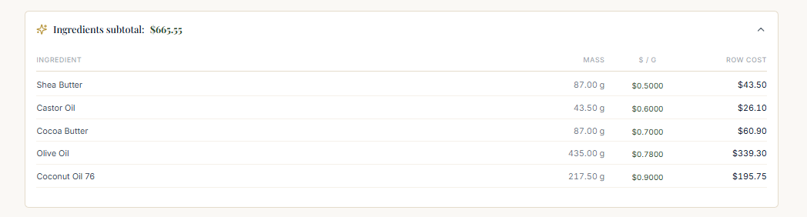
The ingredients subtotal, expanded to a per-line breakdown of mass, cost per gram, and row cost.

The four numbers that matter
Metric | Formula
Direct labor cost | Hourly rate × labor hours worked
Total batch cost | Ingredient subtotal + packaging subtotal + labor cost
Unit COGS | Total batch cost ÷ planned batch output (units)
Suggested retail price | Unit COGS ÷ (1 − target margin %)

Override the retail price manually and the engine flips the last formula around, showing you the effective margin that price actually yields — useful for checking a wholesale price or a promotional discount against your floor before you commit to it.
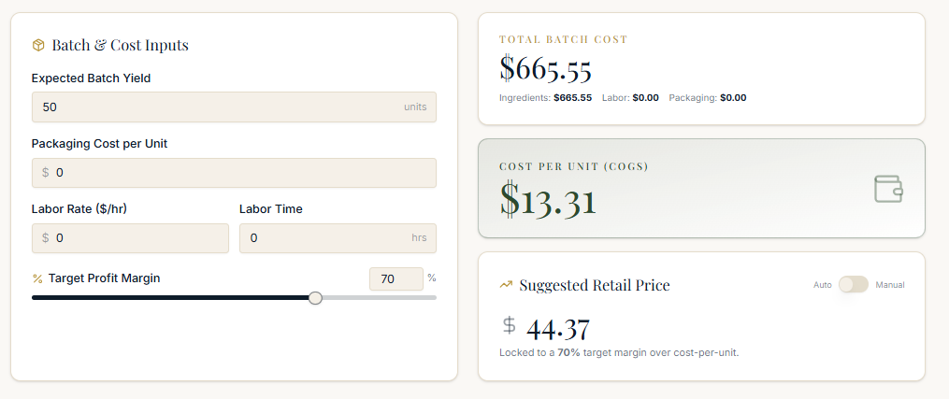
Batch & Cost Inputs on the left; Total Batch Cost, Cost Per Unit, and Suggested Retail Price recalculating live on the right.
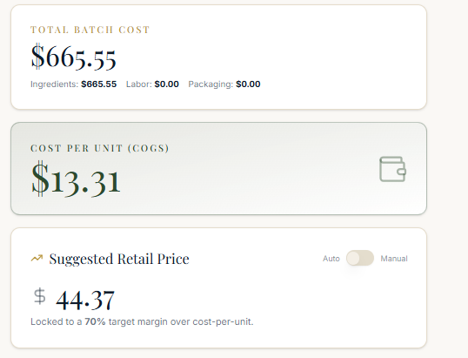
The same three result cards in their stacked layout — total cost, unit COGS, and suggested retail price.

Setting it up
- Open Financials & COGS from the sidebar and select the recipe.
- Enter Expected Batch Yield — how many finished units the batch produces.
- Enter your Hourly Labor Rate and the Labor Time spent compounding and packaging.
- Confirm raw material and packaging costs are attached to the recipe.
- Set your Target Gross Margin % — the Suggested Retail Price locks and updates automatically.
- Or switch to Manual Price Override to test a specific number and see the resulting margin instantly.
- Click Save Financial Profile to Recipe to attach the pricing baseline to your master record.
Formulator tip
Running a wholesale or promotional price test? Use Manual Price Override so you can see, in real time, whether that number still clears your minimum unit-COGS safety threshold before you commit to it.

Batch Log, Curing & Lot Traceability
“Once I pour a batch, tracking curing stages, QC checks, and notes falls apart. I lose track of what's ready to wrap and what needs another week on the rack.”
What Loovay does about it
A five-stage Kanban board follows every batch from pour to shelf-ready, with cure-weight tracking, QC scoring, and supplier lot numbers linked to the same batch ID.

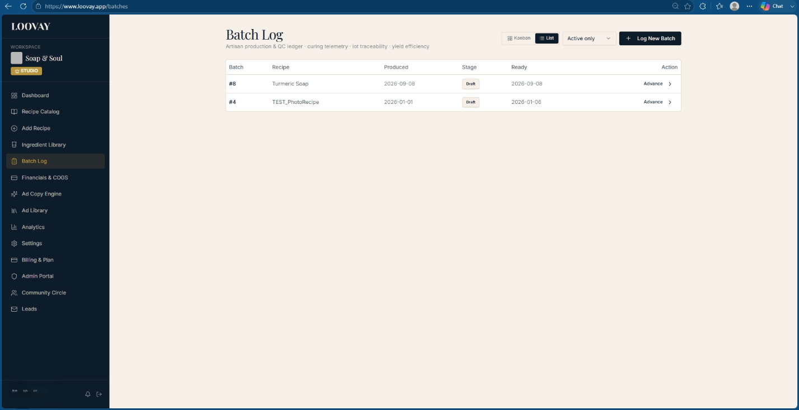
The Batch Log — toggle between Kanban and List view, sorted by stage and readiness date.

The five lifecycle stages
- In Production — active compounding, oil heating, lye mixing.
- Molded / Gelling — poured, undergoing gel phase or thermal hold.
- Cut & Stamped — unmolded, sliced into units, stamped with your logo.
- Curing Chamber — resting on racks for water evaporation and crystal-lattice stabilization.
- QC Passed & Ready — cleared pH, lather, and weight checks; moved to the Finished Goods Vault.
Each card shows a batch code, linked recipe name, a circular cure-countdown ring ("Day 14 / 28"), ambient room temperature and humidity, and color-coded status badges: pH Verified, Weight Stabilized, or a red Variance Flagged if yield or weight loss falls outside range.

Starting a batch
- Click + Log New Batch, select the target recipe, and enter the curing duration in days — the target readiness date calculates automatically.
- Click Create Batch to generate a unique Batch ID.
- Assign a supplier lot number to every raw material line item under Trace & Yield — this is what makes a recall audit instant instead of a week of digging through paper notes.
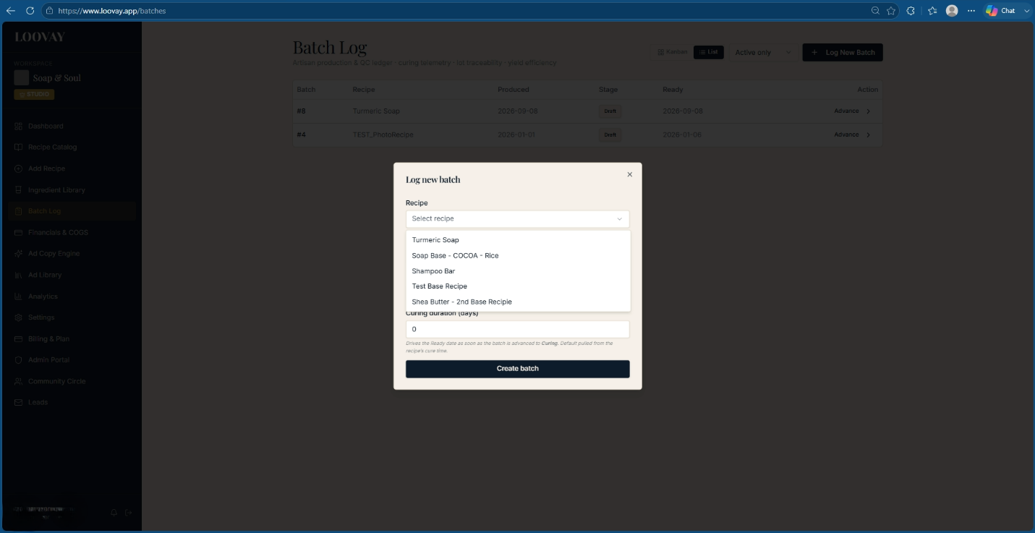
The Log New Batch modal — pick a recipe from your catalog and set the curing duration to generate a Batch ID.

Logging production telemetry
Inside the batch, the Precision Log tab captures the numbers that actually predict a good cure: lye temperature, oil temperature, time-to-trace in minutes, unmold time, and gel-phase condition (full gel, partial gel, or inhibited). The engine flags a thermal mismatch of more than 5°C between the lye solution and oil phase at combination.
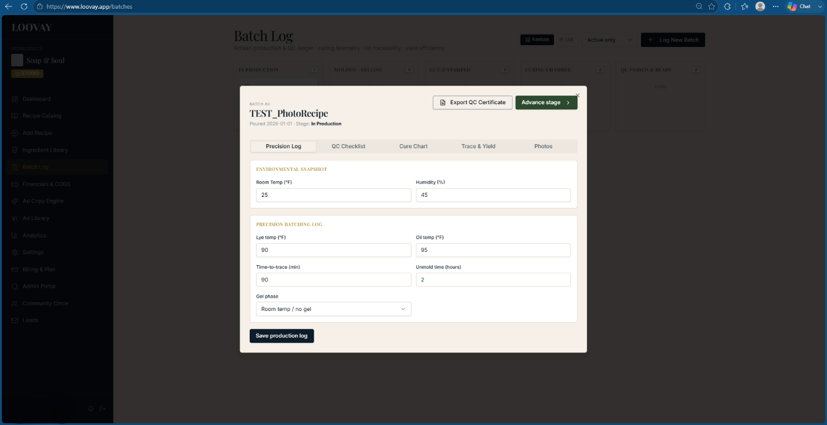
The Precision Log tab — environmental snapshot and batching telemetry logged against the active batch card.
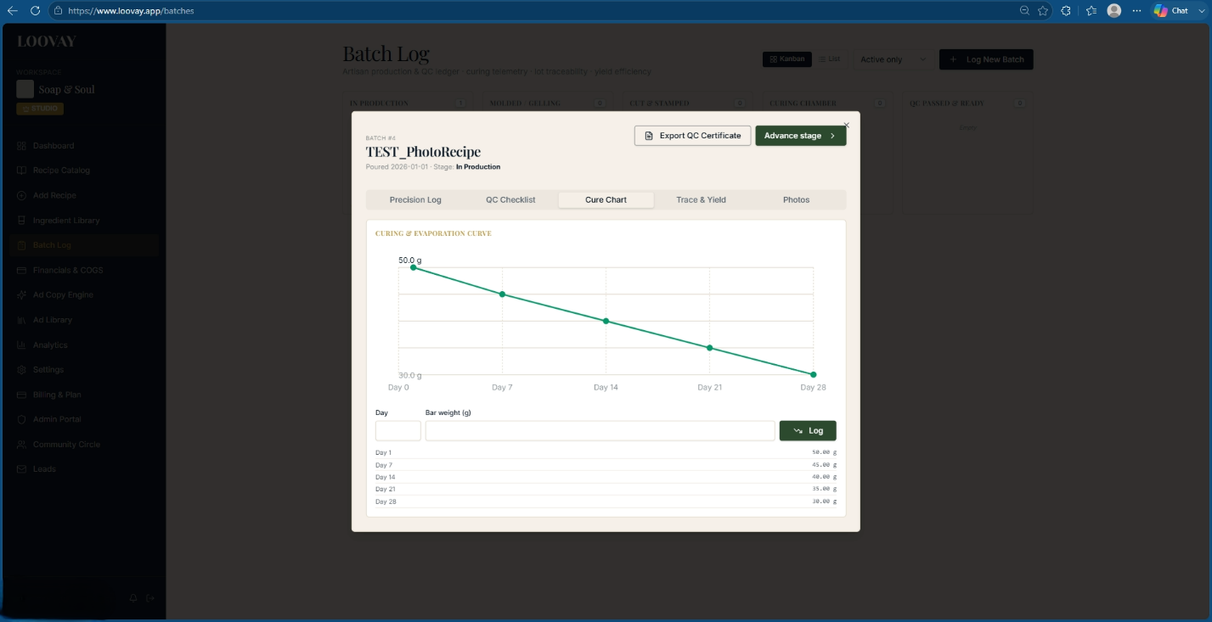
Weekly cure-weight entries plotted as an evaporation curve; the batch is flagged complete once the slope flattens.

Tracking the cure
Weigh a sample bar weekly and log the mass. The engine plots the water-loss curve automatically:
Formula | Meaning
Evaporation % = (Day 1 weight − current weight) ÷ Day 1 weight × 100 | Once weekly moisture loss drops under 0.5% for a full week, the batch is flagged Cure Complete

Quality control before release
QC check | Pass target
Pre-cure pH | 10.0 – 11.5 (at unmolding)
Post-cure pH | 8.5 – 9.5 (fully cured)
Lather score (1–5) | ≥ 4.0
Scent retention (1–5) | ≥ 4.0
Bar hardness (1–5) | ≥ 4.0, firm edges, no sticky core

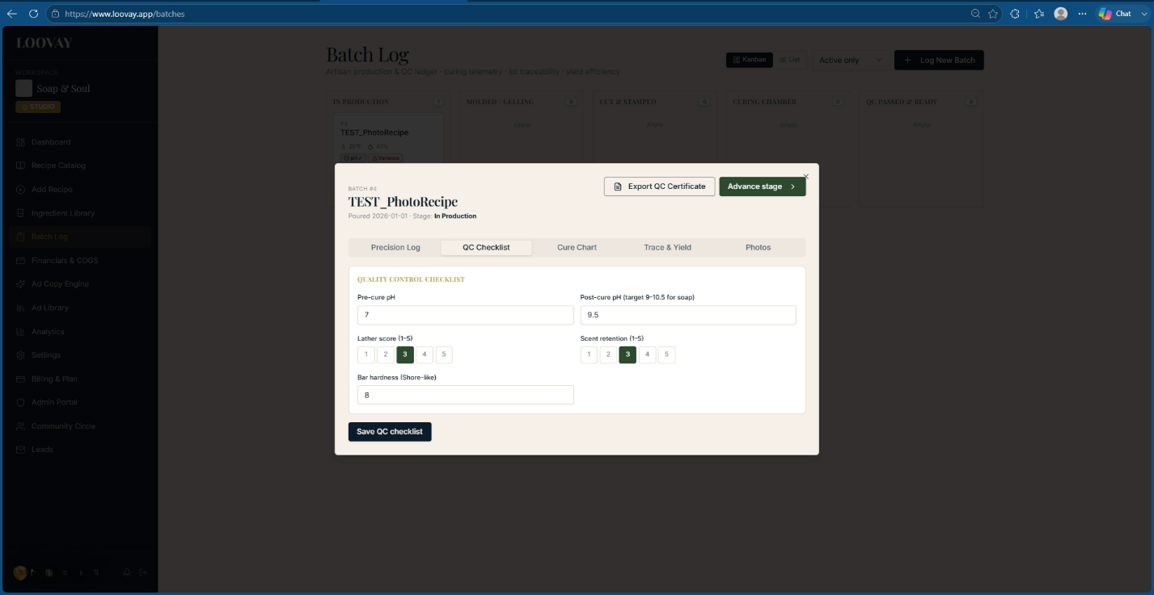
The QC Checklist tab — pre- and post-cure pH, lather score, scent retention, and bar hardness, logged against the batch card visible behind it.
Enter results in the QC Checklist tab, then use Advance Stage to move the batch forward. Click Export QC Certificate at any point for a printable lot report.

Lot traceability and yield
Every ingredient line maps to the supplier lot code you entered — click any code to generate a bi-directional recall map showing exactly which finished units and customer orders contain material from that lot. Yield efficiency is calculated as usable finished weight divided by total expected batch yield; anything trimmed or scrapped logs as Trim Weight and folds straight into unit COGS.
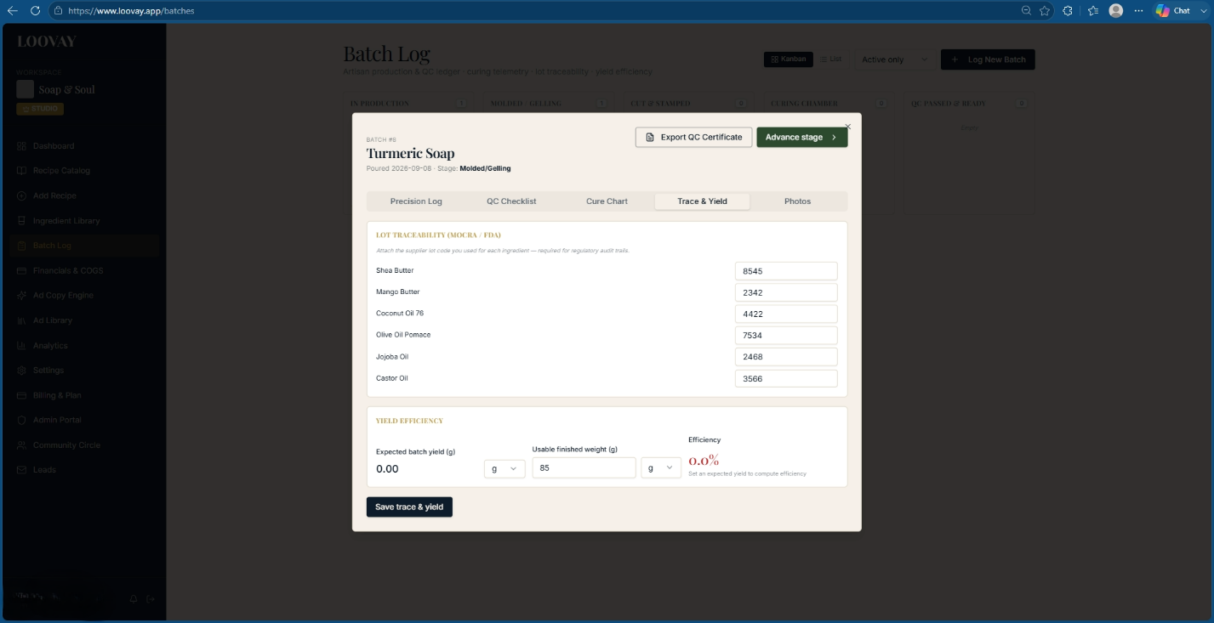
The Trace & Yield tab in full — supplier lot codes on the left, expected-versus-usable yield on the right.
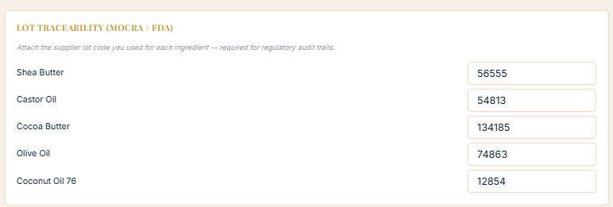
A closer look at the lot-code fields: one supplier lot number attached to every raw material in the batch.
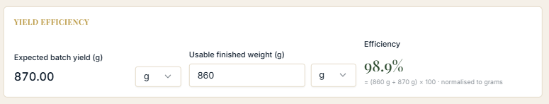
Yield Efficiency: expected batch yield against usable finished weight, calculated live as a percentage.
Formulator tip
Yield efficiency dropping under 92%? Check your Trim Weight logs — clean soap trimmings can be re-routed into inventory as a "rebatch / soap shreds" raw material to recover some of that cost.

Exporting a QC certificate
Click Export QC Certificate on any batch to generate a dated, printable lot report — batch ID, QC results, curing and weight-loss data, environmental conditions, and every supplier lot code, all on one page you can hand to a retailer or keep for your own compliance file.
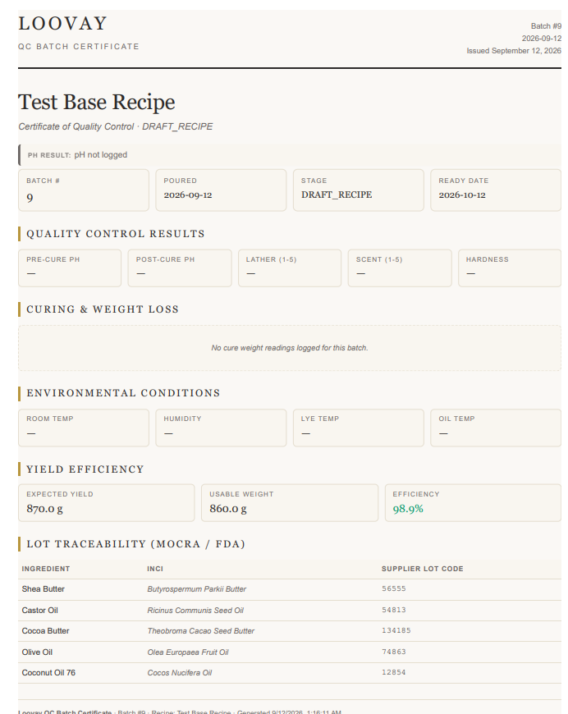
An exported QC Batch Certificate — quality results, environmental conditions, yield efficiency, and full lot traceability in one document.

The Adaptive Scale-Up Assistant
“My test batch was perfect, but the full production run separated and the scent vanished. The heat and mixing dynamics completely changed and I don't know how to adapt the steps.”
What Loovay does about it
The scale-up assistant adjusts phase mixing, temperature holds, and cooling rates automatically as batch volume grows, so texture and scent throw hold at commercial scale.

Scaling the batch
Update the Total Batch Oil Weight field — from a 1 kg bench sample up to a full tank size — and pick your unit (g, kg, oz, lb). Every ingredient recalculates automatically, preserving the exact percentage ratios from your original test batch.
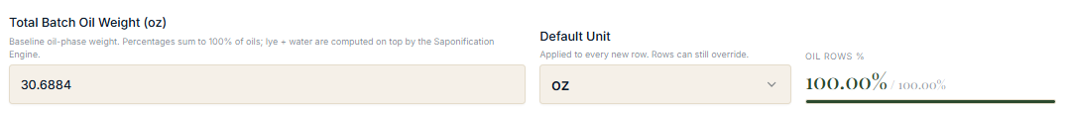
Total Batch Oil Weight and Default Unit — every ingredient row recalculates off this one field.

Phase and thermal controls
Assign each raw material to Phase A, B, or C, and set a processing and hold temperature for each — larger batches carry more thermal mass, so a temperature that worked at 1 kg won't behave the same at 50 kg. Keep heat-sensitive fragrance and botanicals in a cool-down phase to protect scent throw from flashing off during large-volume mixing.
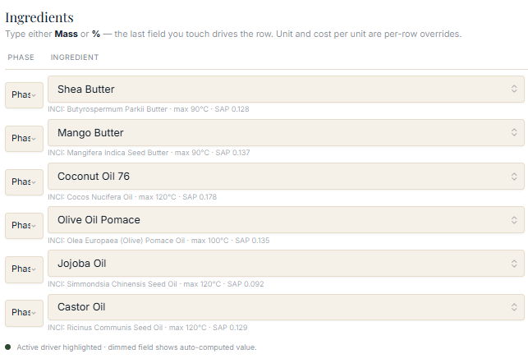
Ingredient rows carrying their phase, INCI name, thermal max, and SAP value as the batch scales.

Verifying before you commit
- Check the Formulation Guardrails panel for automated stability warnings before scaling up further.
- Watch the Ingredient Cost panel — cost scales with volume, and this is the moment to catch a pricing surprise before the batch is poured.
- Click Save Recipe to lock in your scale-up parameters.

The Ad Copy Engine & Ad Library
“I am a chemist at heart, not a marketer. Staring at a blank screen trying to write captions that actually convert makes me freeze up, and generic AI copy sounds like a boring robot.”
What Loovay does about it
The Ad Copy Engine turns your recipe's actual ingredients and benefits into platform-tailored copy, built on proven persuasion structure instead of a blank page.

Setting the campaign parameters
- Recipe — the specific formula you're featuring.
- Buyer stage — Awareness, Consideration, or Action (purchase).
- Platform — Facebook, Instagram, or another channel.
- Life Force 8 trigger — the core psychological angle: comfort, fear of loss, ingredient authority, aspirational identity, and others.
Click Generate 3 Variants.
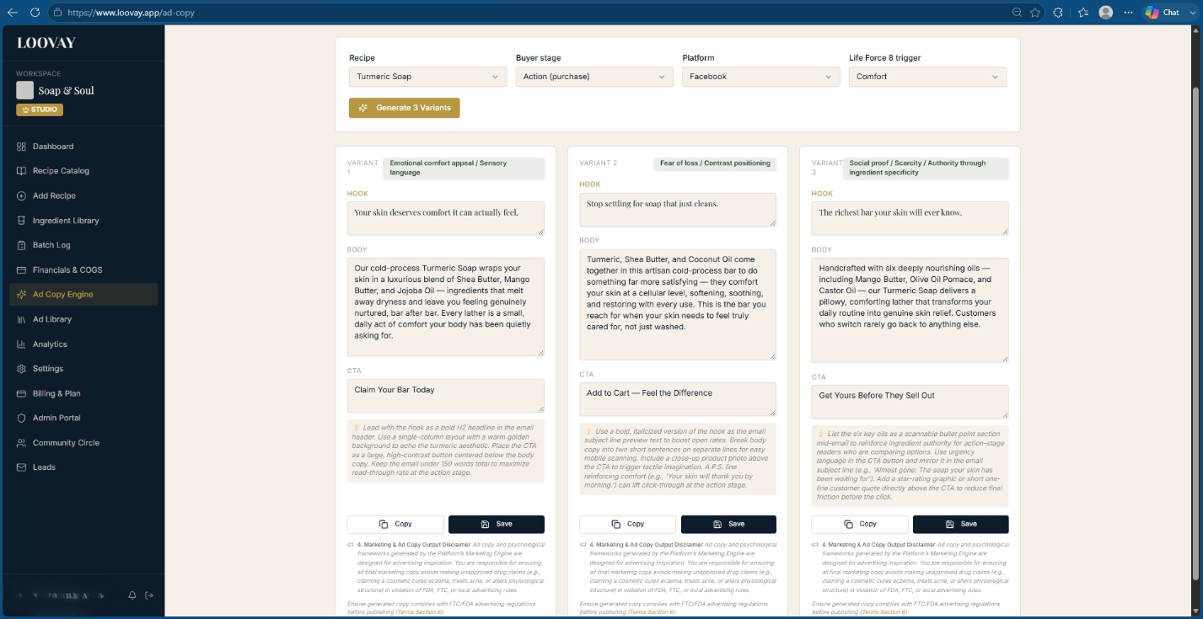
The Ad Copy Engine — recipe, buyer stage, platform, and psychological trigger feed three generated variants.

Reading a copy card
- Hook — the opening line built to interrupt scrolling ("Your skin is quietly begging for a break.")
- Body — narrative copy drawn directly from your recipe's real ingredients and skin benefits.
- Call to action — a conversion line matched to the buyer stage ("Claim your bar today," "Try it risk-free for $12.")
- Implementation hints — placement guidance for email layout, font styling, or creative pairing.

Saving and managing copy
Click Copy to paste a variant straight into your social scheduler, or Save to file it in the Ad Library. From the library, filter by platform or click Export to download your full saved campaign for launch.

The Ad Library — saved copy cards, filterable by platform, ready to export for launch.
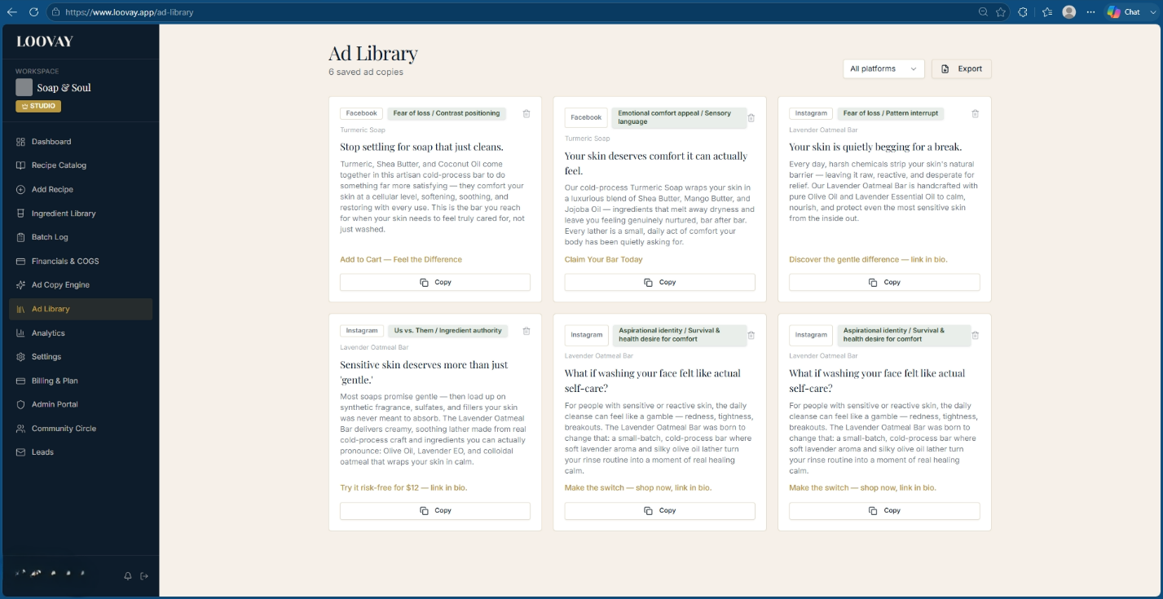
The full Ad Library grid: six saved copies, each tagged with its platform and psychological angle.

Performance Analytics & Workspace Settings

Studio metrics
Analytics rolls up production throughput, yield efficiency, and margin trends across your whole recipe catalog and batch history — the view to check before deciding whether to raise a wholesale price or push harder on a slow-moving product line.
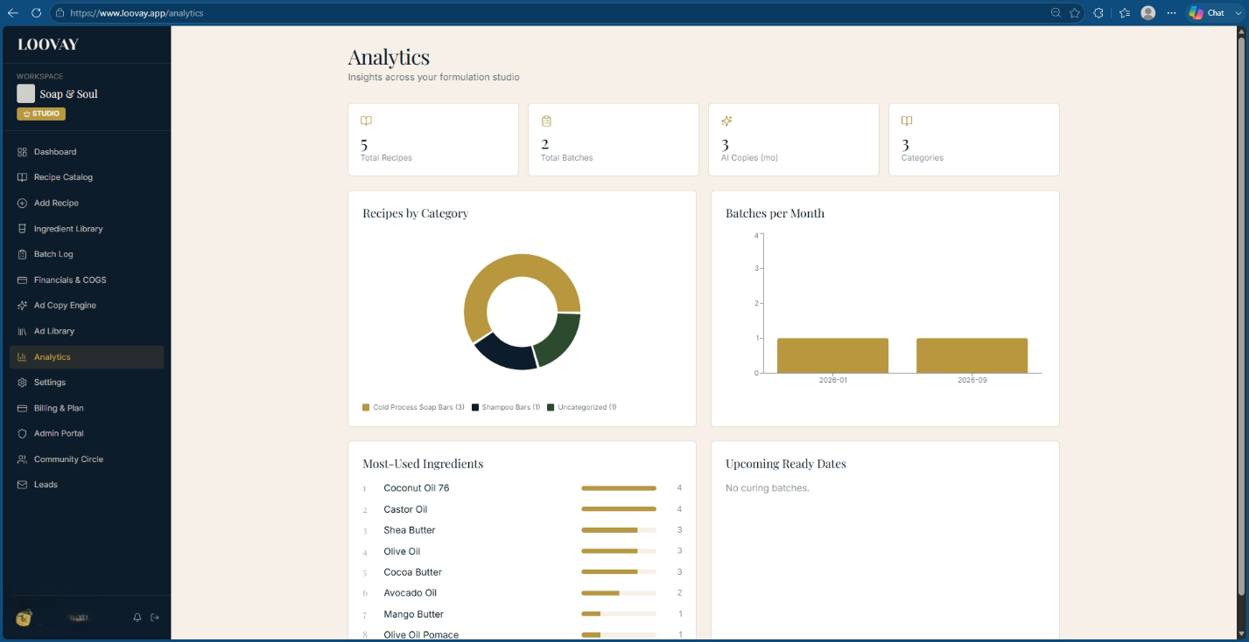
The Analytics dashboard — throughput, yield efficiency gauges, and margin trend lines in one view.

Workspace settings and billing
Settings holds your unit-conversion defaults, compliance jurisdiction profile, and workspace details. Billing & Plan is where subscription tier, usage metering (active recipes, AI generations, PDF exports), and payment details live.
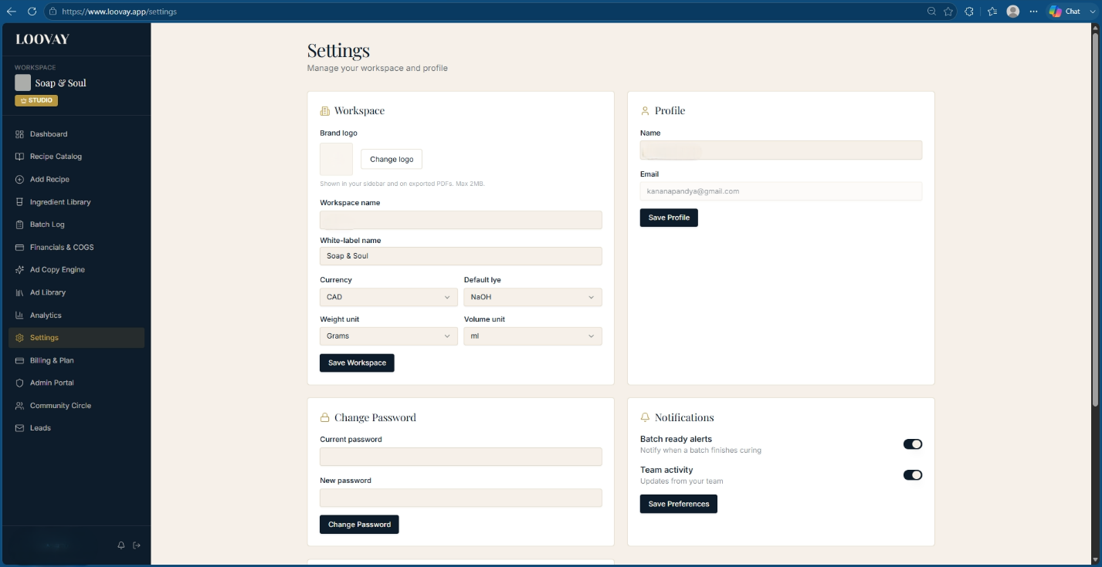
Workspace Settings — unit conversions, compliance profile, and account-level configuration.

Loovay Circle: Community & Peer Support
“None of my friends or family understand formulating, supplier headaches, or batch failures. When something goes wrong, I feel like I'm completely on an island.”
What Loovay does about it
Loovay Circle is a peer network built specifically for formulators — structured Q&A, real-time batch troubleshooting, and a reputation system that surfaces the people who actually know what they're talking about.

Finding your way around
Click Community Circle in the left sidebar to reach the dashboard: leaderboard rankings, active discussion threads, and a category filter. Searching or tagging a thread uses a live auto-suggest box — type a keyword like "preservative" or "pH drift" and matching topics surface instantly across a taxonomy of 15 categories, from Emulsions & Lotions to Regulatory & INCI Standards.
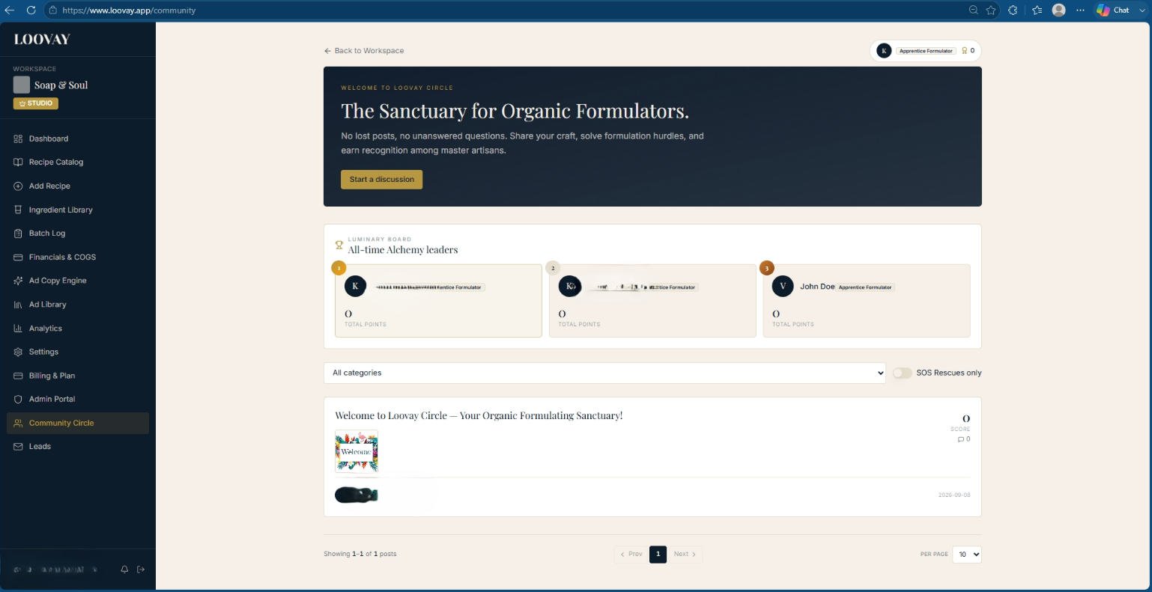
The Community Hub dashboard — the Luminary Board leaderboard, an SOS-Rescues-only toggle, and the active discussion feed.
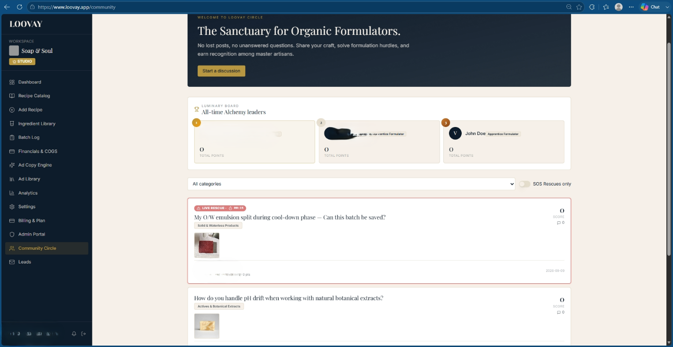
The discussion feed, with an active SOS Rescue thread flagged red and pinned above regular posts.

Posting a discussion
- Click Start a Discussion and give it a specific title — "My O/W emulsion split during cool-down — can this batch be saved?" beats a vague one.
- Describe your recipe's grams, phases, temperatures, and exactly where it went wrong.
- Tag up to five relevant categories.
- Attach batch or product photos for visual context.
As you type your title, a duplicate-prevention panel checks it against already-solved threads in real time, so you often get an answer before you even post.
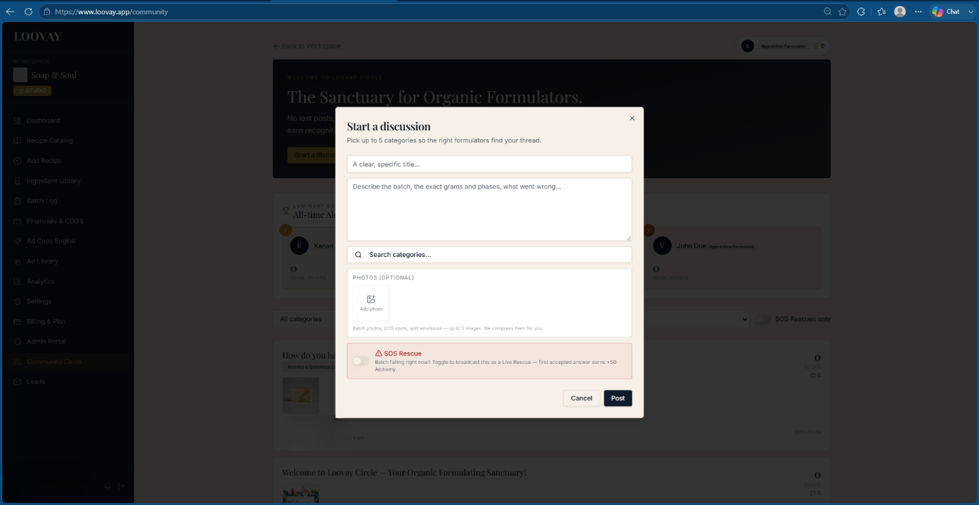
Starting a discussion — title, description, category tags, and optional photos.
Once posted, the thread opens with your question, any attached photo, and an upvote/downvote rail on the left — with an answer box waiting at the bottom for the first formulator who has a fix.
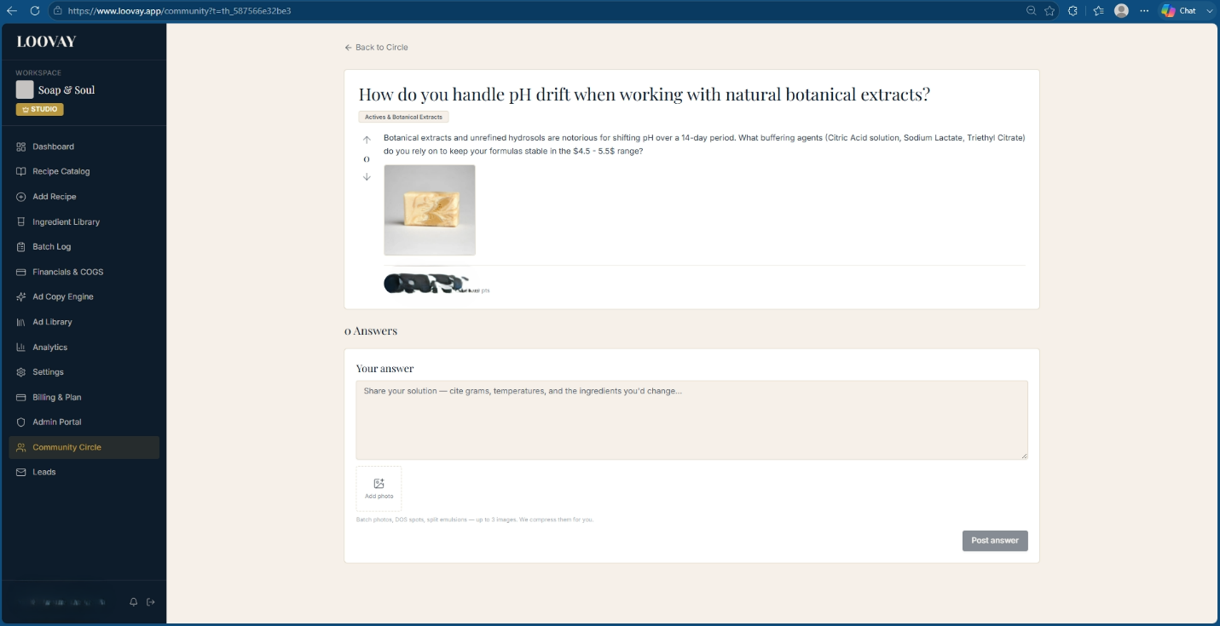
An open discussion thread — question, batch photo, and the answer box where the next formulator responds.

The SOS Rescue system
A batch actively seizing, ricing, or separating on the bench can't wait hours for a forum reply. Toggle SOS Rescue at the bottom of the discussion form, describe the failure, and publish — the thread renders with a glowing, high-contrast LIVE RESCUE badge and a live timer counting up from the moment it was triggered.
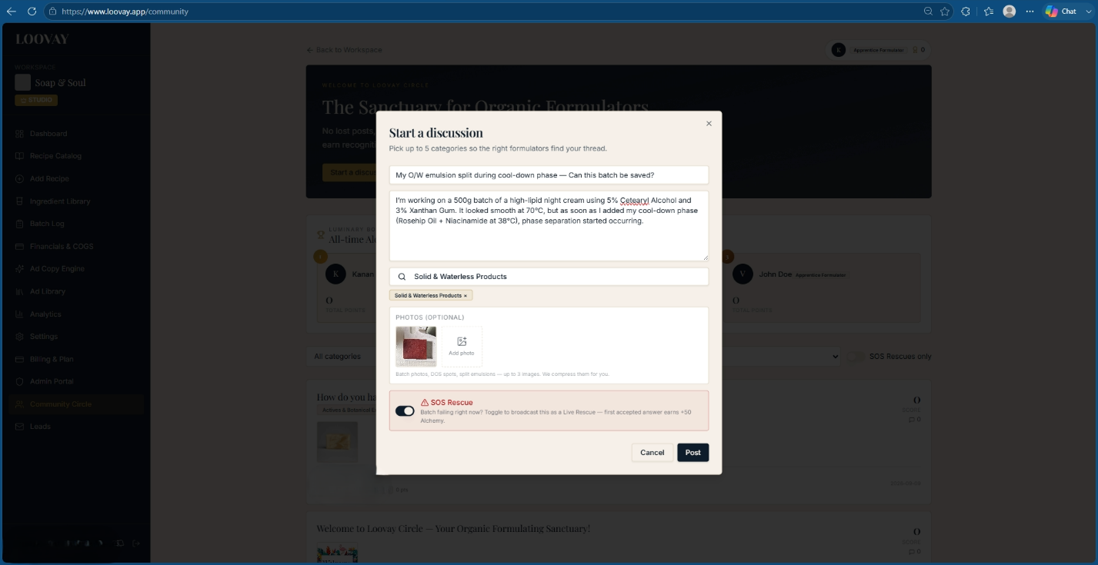
An active SOS Rescue thread — pulsing badge, live timer, broadcast across the community feed.

Reputation, tiers, and badges
Total Alchemy Score = upvotes + accepted answers + SOS rescues − downvotes.
Action | Points
Your answer is upvoted | +10
Your answer is marked accepted | +15
Your answer resolves an SOS Rescue | +50
Your question is upvoted | +5
Your content is downvoted | −2

Tier | Points
Apprentice Formulator | 0 – 99
Botanical Artisan | 100 – 499
Master Emulsifier | 500 – 1,999
Grand Alchemist | 2,000 – 4,999
Legendary Chemist | 5,000+

- First Responder — answers an SOS thread within 15 minutes of posting.
- Preservation Guardian — 5 accepted answers under Preservation & Microbiology.
- Circle Luminary — top 3 point earners platform-wide for the month.

Quick Reference

Physical property targets
Property | Target range
Hardness | 29 – 54
Cleansing | 12 – 22
Conditioning | 44 – 69
Bubbly lather | 14 – 46
Creamy lather | 16 – 48
Iodine value | 41 – 70
INS score | 136 – 165

Key constants
- KOH ÷ NaOH molar mass ratio: 56.105 ÷ 39.997 ≈ 1.40275
- Pure NaOH minimum water-to-lye ratio for full dissolution at room temperature: 0.9:1 (engine flags below 1.1:1 as a solubility risk)
- Allergen disclosure threshold, rinse-off products: 0.01% (100 ppm)
- Allergen disclosure threshold, leave-on products: 0.001% (10 ppm)

Curing and QC targets
Check | Target
Pre-cure pH | 10.0 – 11.5
Post-cure pH | 8.5 – 9.5
Cure complete threshold | Weekly moisture loss under 0.5%
Standard CP cure window | 4 – 6 weeks
Yield efficiency floor to investigate | Below 92%

Glossary
- SAP value — the amount of alkali (g) required to fully saponify 1 g of a given lipid.
- Superfat / lye discount — the percentage of oil left deliberately unreacted with alkali.
- Trace — the point at which the soap batter thickens enough to hold a temporary pattern on the surface.
- INS score — SAP value minus iodine value; a general indicator of overall bar balance.
- INCI — International Nomenclature of Cosmetic Ingredients; the standardized naming system used on ingredient labels worldwide.
- Pre- vs. post-saponified labeling — listing raw starting oils and lye versus listing the soap salts and glycerin actually formed by the reaction.

